Note for building Retail Manager

**Table of Contents**

1 Introduction 2

2 GitHub account 2

2.1 Created new repository below 3

2.2 Clone the repository 4

2.3 Main branch vs. Master branch 4

2.4 Git Pull 5

2.5 Git status 5

3 Connect GitHub with Visual Studio 5

3.1 Comment changes 11

3.2 Git pull then git push (or Sync in Visual Studio) 12

3.3 Suggested to do a git fetch before git pull 13

3.3.1 Difference between git fetch and git pull 13

4 Creating Empty Solution Using Visual Studio 14

4.1 Open Visual Studio -> Create new project -> Blank Solution 14

4.2 Give the solution and folder as the folder of the repository 15

4.3 The solution is created 15

5 Create ASP.NET Web Application (.NET Framework) Project 16

5.1 With individual User Accounts Authentication 17

5.2 MVC folders are added to web API project 18

5.3 Updated NuGet except bootstrap 19

5.4 Route for MVC is at RouteConfig.cs 21

5.5 Route for API is at WebApiConfig.cs 22

5.6 Configuration for user validation e.g. rules for username and password in IdentiftyConfig.cs 22

5.7 MVC controller 23

5.8 API controller 23

6 Run the app and see the API help page 23

7 Register a user with Sample User information 25

8 Get access token 26

8.1 Question? 27

8.1.1 Answer 27

9 Get values of the user 27

9.1 Need to get the token see Section 8 27

9.2 Get values of the user by using the token 28

10 Location of user data stored 28

11 Add userId obtained from the get request https://localhost:44375/api/values 29

11.1 Add “using Microsoft.AspNet.Identity;” 30

11.2 Get and assign userId in the get function 30

11.3 Return the userId 31

11.4 Tested the end point with Postman returning the userId below 31

12 Difference between API controller and MVC controller 31

13 Configuring Swagger WebAPI 32

13.1 Add swagger into the WebApi 32

13.2 Browse swagger WebApi 35

13.3 Configuring Swagger in SwaggerConfig.cs 37

13.3.1 Configuring Swagger, example: Change the display name of the api to “Retail Manager API - version 1” as 2 screenshots below : 38

13.3.2 Configuring Swagger, example: enable PrettyPrint() as below: 39

13.3.3 Configuring Swagger, example: enable DescribeAllEnumsAsStrings() as below: 40

13.3.4 Configuring Swagger, example: change the title on the tab as 2 screenshots below : 40

13.4 Make token endpoint available in Swagger 41

13.4.1 Add a new class “AuthTokenOperation.cs” in App_Start 41

13.4.2 Inherited & implemented interface “IDocumentFilter” & added “using Swashbuckle.Swagger;” 42

13.4.3 Gave concrete implement of the interface “IDocumentFilter” 44

13.4.4 Update SwaggerConfig.cs accordingly 44

13.4.5 Run the code to see swagger ui 46

13.4.6 Use the post in Auth of the Swagger UI 46

13.5 Add token header parameter into every end point in Swagger 48

13.5.1 Added class AuthorizationOperationFilter inherited from IOperationFilter 48

13.5.2 Added c.OperationFilter<AuthorizationOperationFilter>(); into SwaggerConfig.cs 49

13.5.3 Showed the additional token header parameter field in every endpoint of Swagger 49

13.6 Disable Swagger 50

# Introduction

Learning ASP.Net from:

TimCo Retail Manager Course

https://www.youtube.com/watch?v=TDuG1WU3GvM&list=PLLWMQd6PeGY0bEMxObA6dtYXuJOGfxSPx&index=2

# GitHub account

## Created new repository below

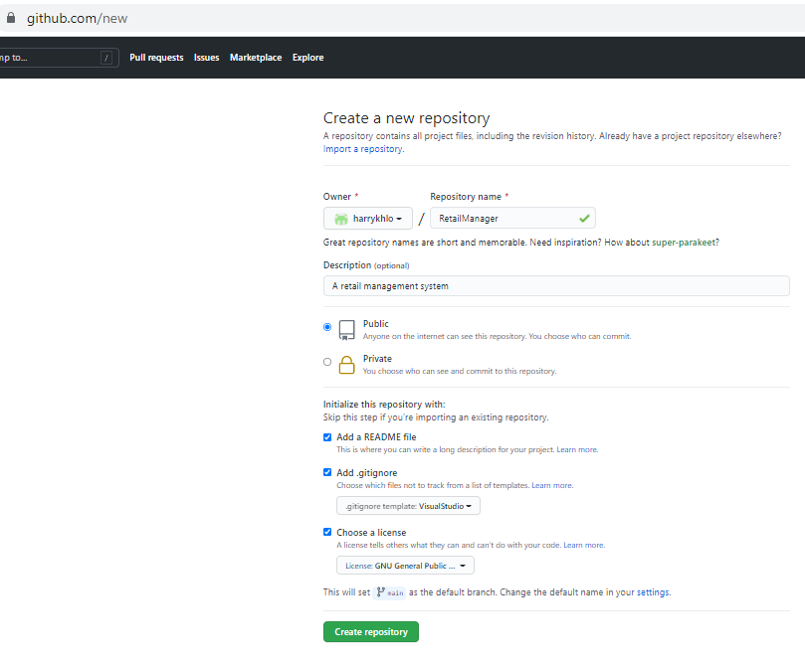

## Clone the repository

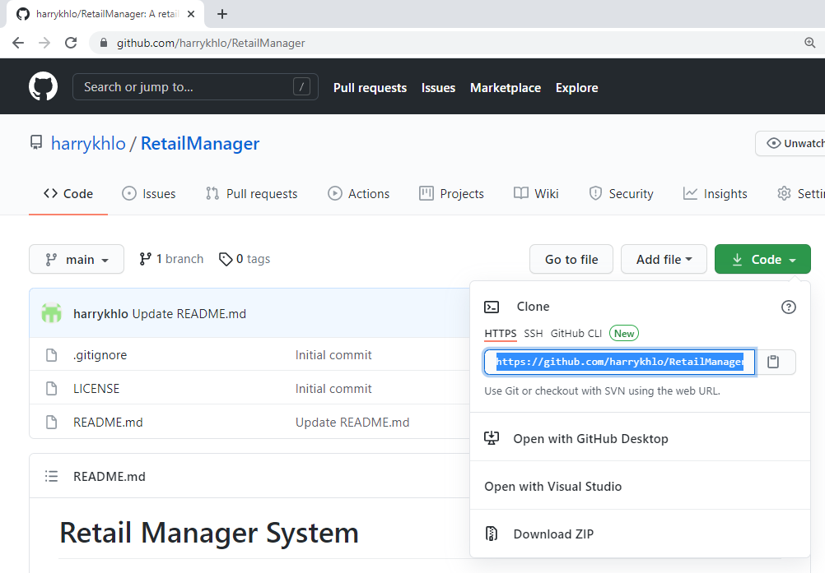

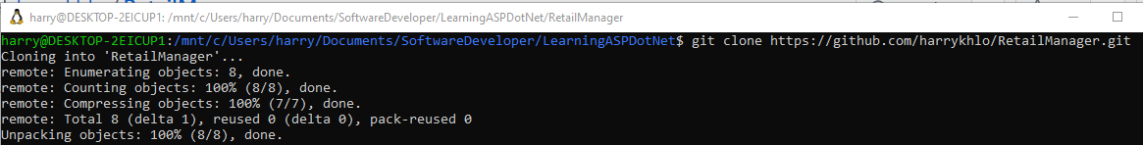

## Main branch vs. Master branch

refer: <https://stackoverflow.com/questions/64249491/difference-between-main-branch-and-master-branch-in-github>

GitHub is working on replacing the term "master" on its service with a neutral term like "main" to avoid any unnecessary references to slavery,

You can read here for more background the reason for the change here: <https://www.zdnet.com/article/github-to-replace-master-with-alternative-term-to-avoid-slavery-references/>.

About renaming your branch from master to main, there are a lot of guidelines. For example: <https://jarv.is/notes/github-rename-master/>.

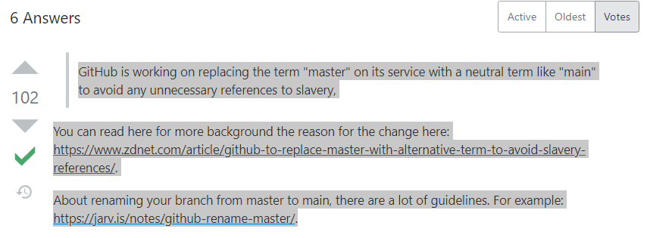

## Git Pull

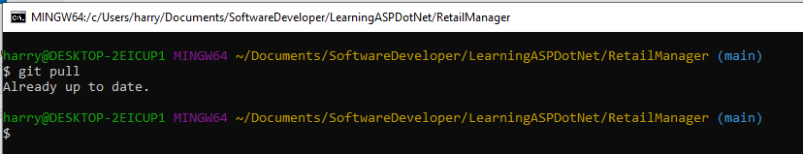

## Git status

Git status after create a new blank solution

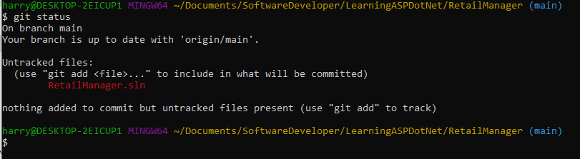

# Connect GitHub with Visual Studio

From Visual Studio

-> Manage Extensions -> GitHub Extension for Visual Studio ->

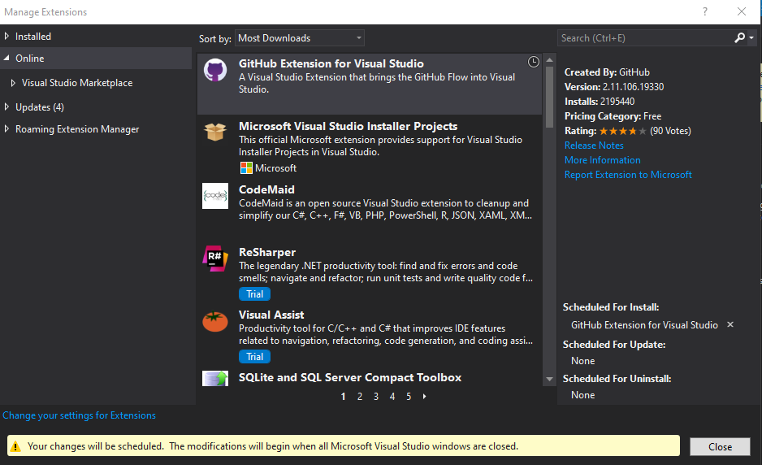

Close Visual Studio -> the extension will be installer automatically

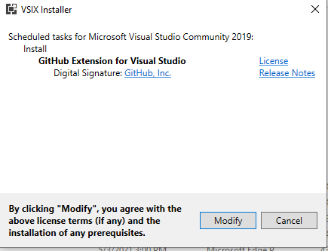

Open the visual studio again -> Team Explorer -> GitHub -> Connect…



Sign in GitHub

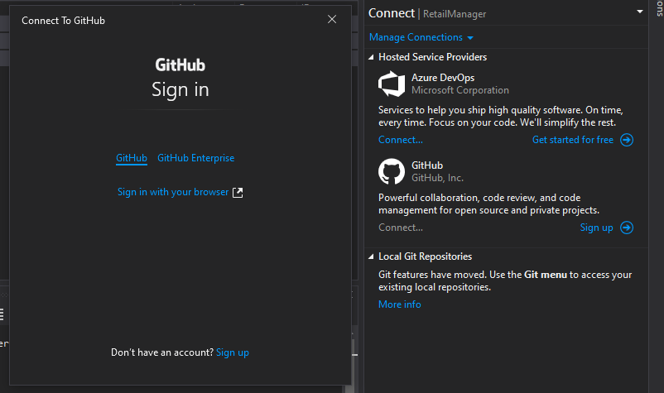

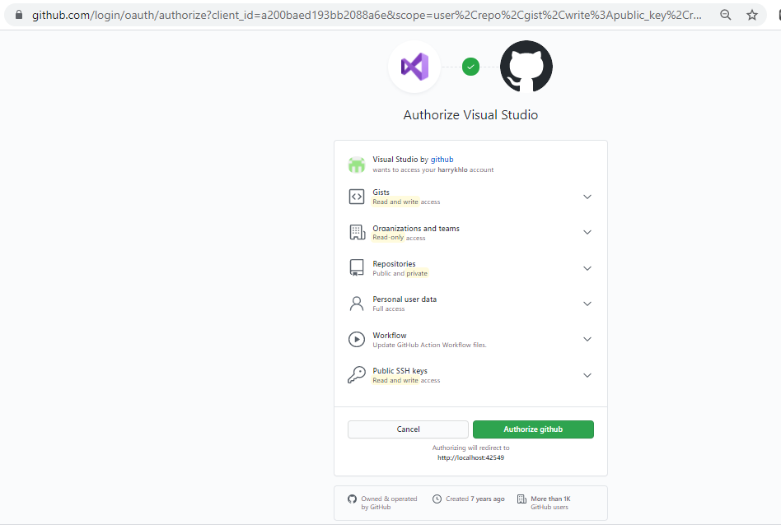

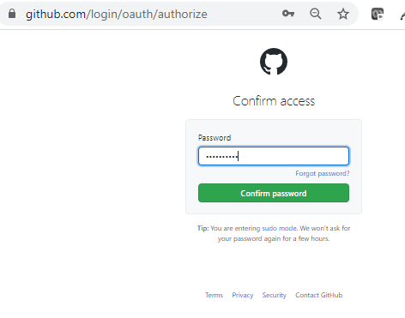

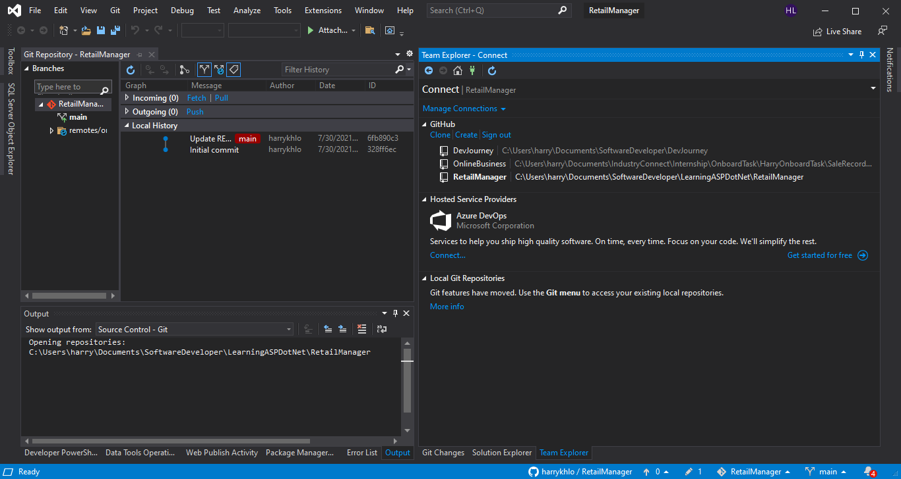

Select correct repository by double clicks

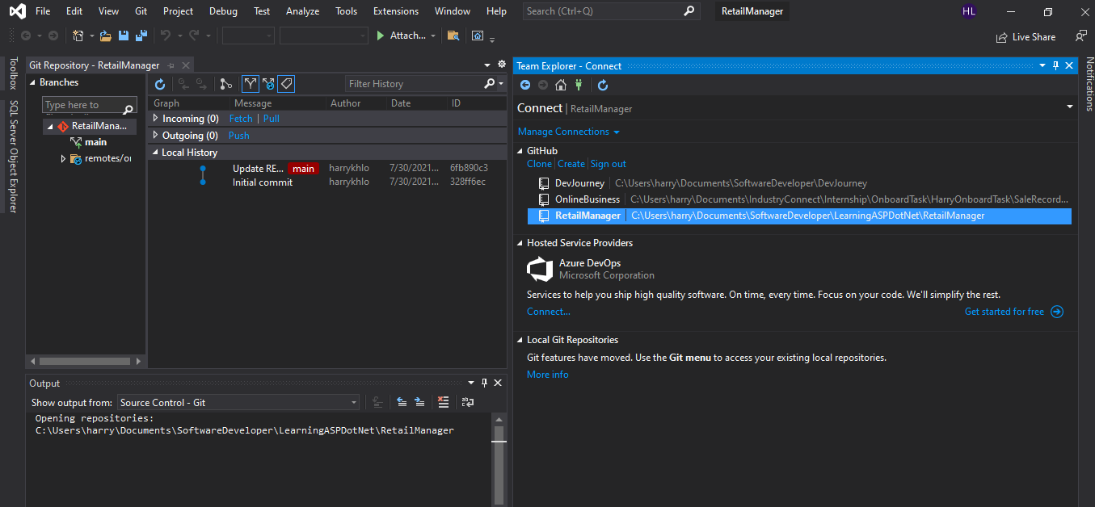

Select Git change

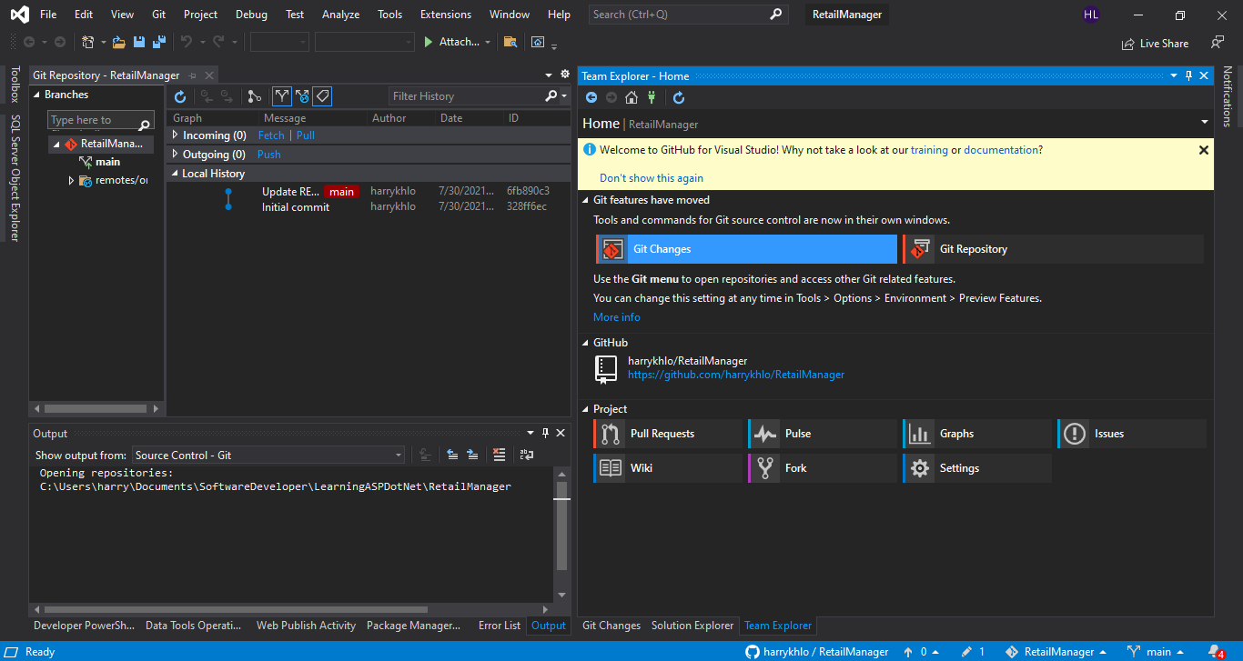

Right click the changed file and select “Stage”

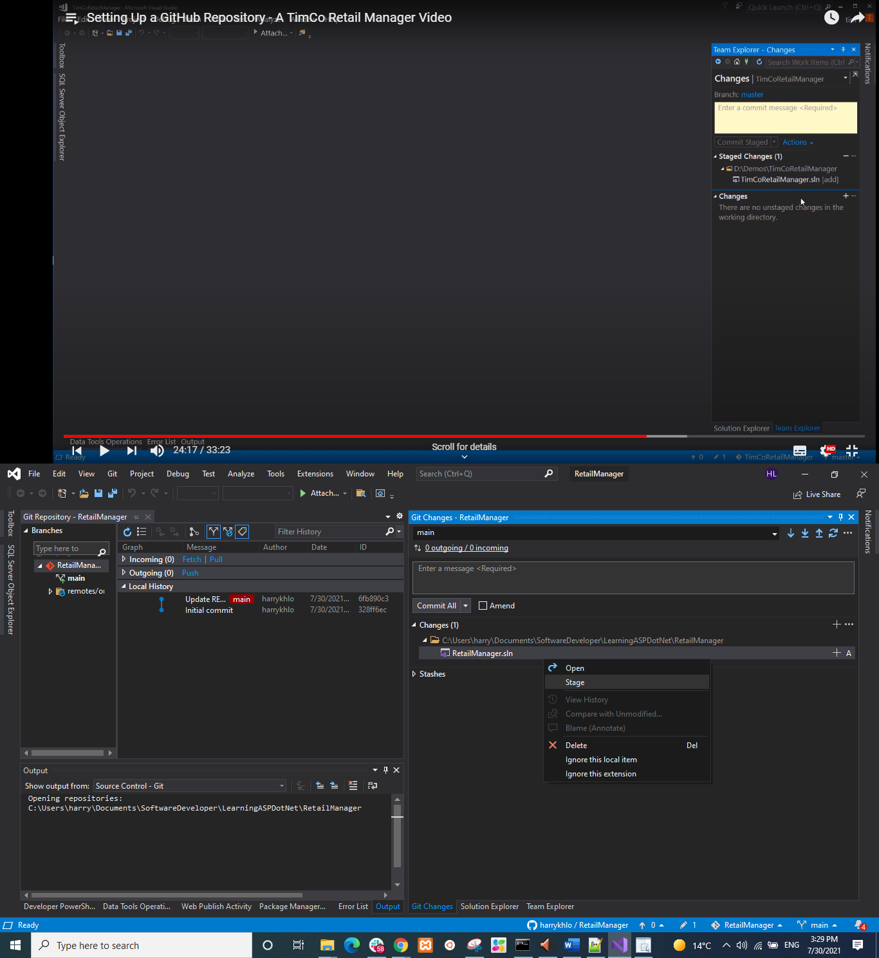

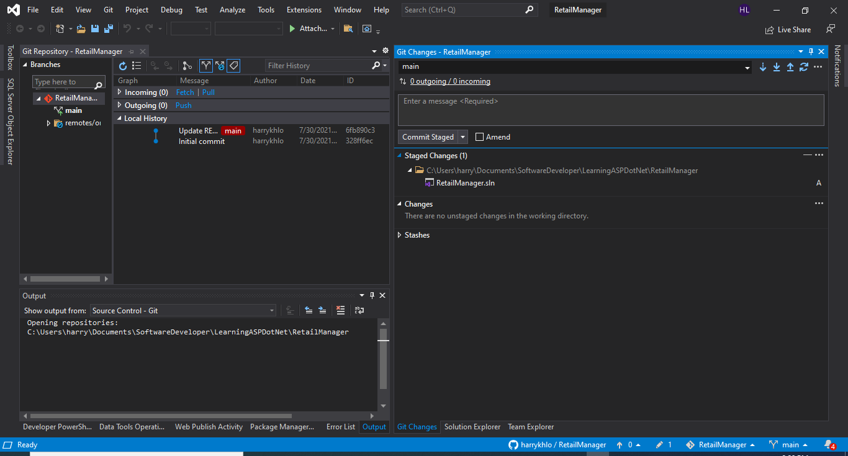

## Comment changes

Add comment message

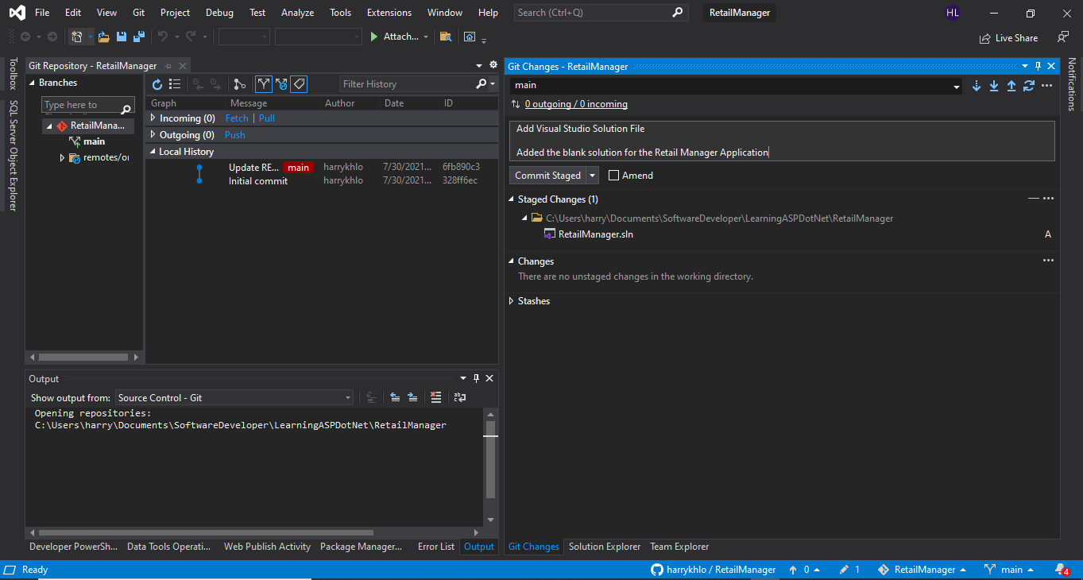

Click “commit staged” above and will show below that the change is committed locally

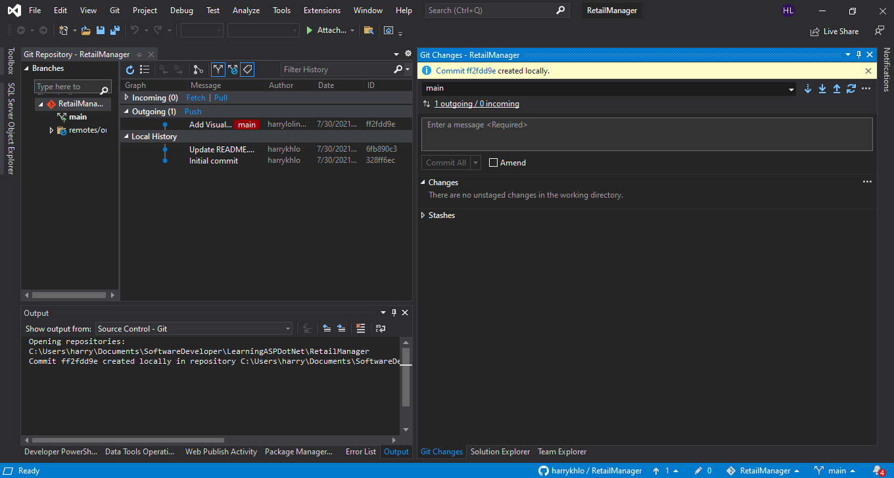

Git status in command line will show below

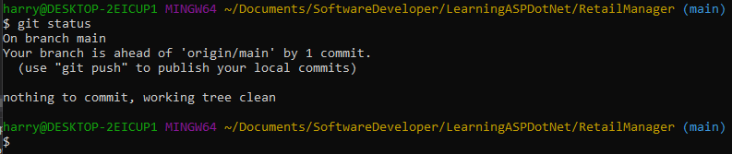

## Git pull then git push (or Sync in Visual Studio)

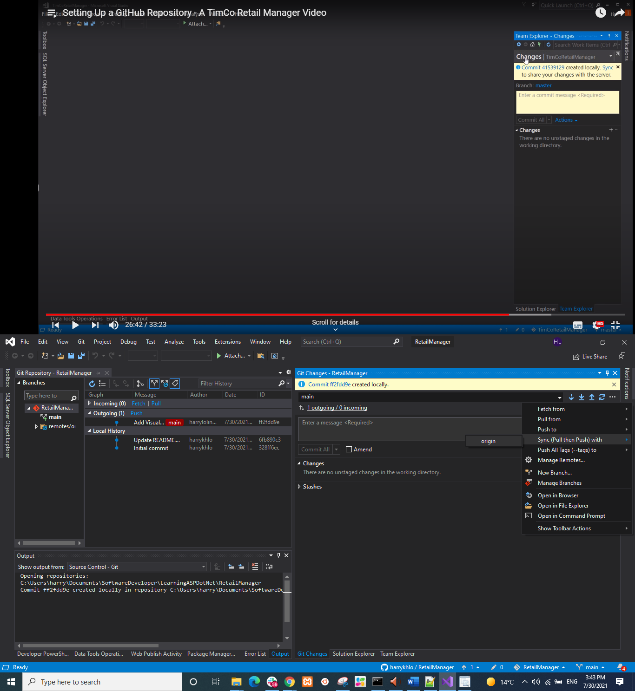

After sync

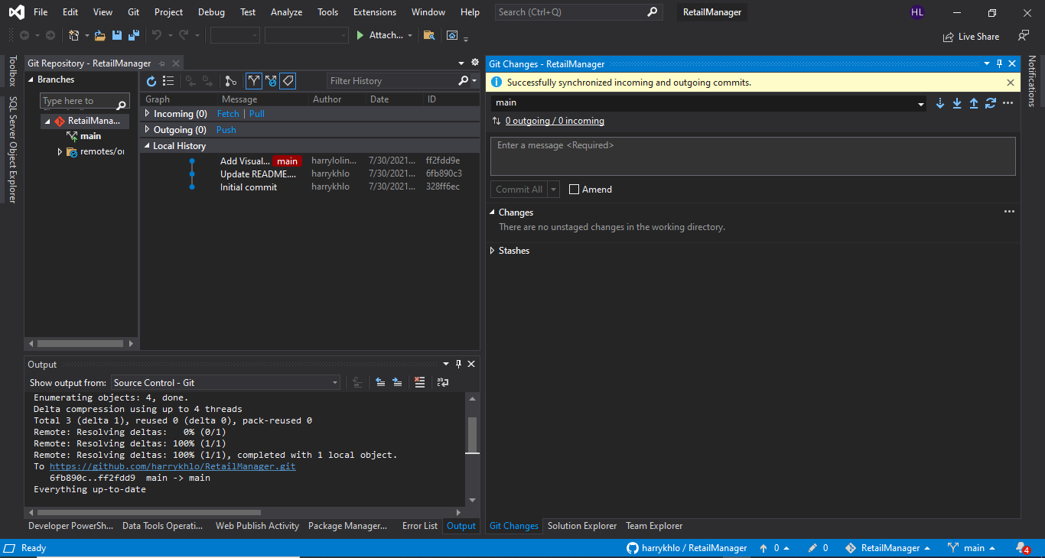

## Suggested to do a git fetch before git pull

### Difference between git fetch and git pull

<https://www.freecodecamp.org/news/git-fetch-vs-pull/>

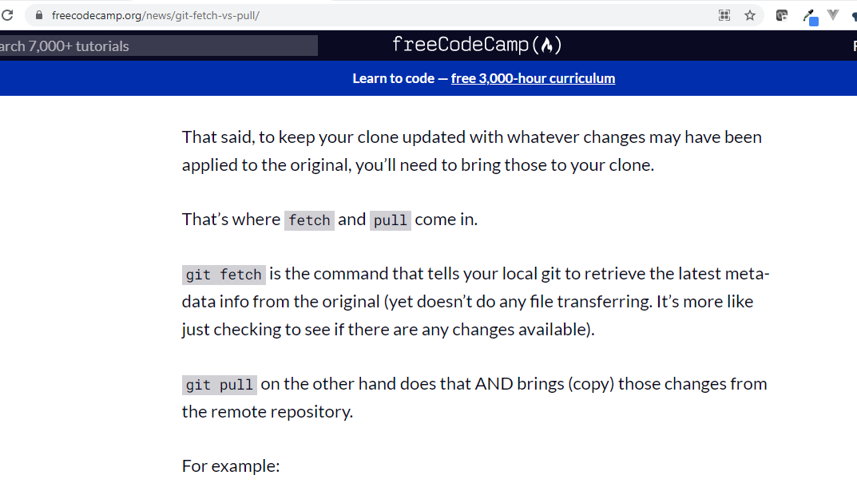

# Creating Empty Solution Using Visual Studio

## Open Visual Studio -> Create new project -> Blank Solution

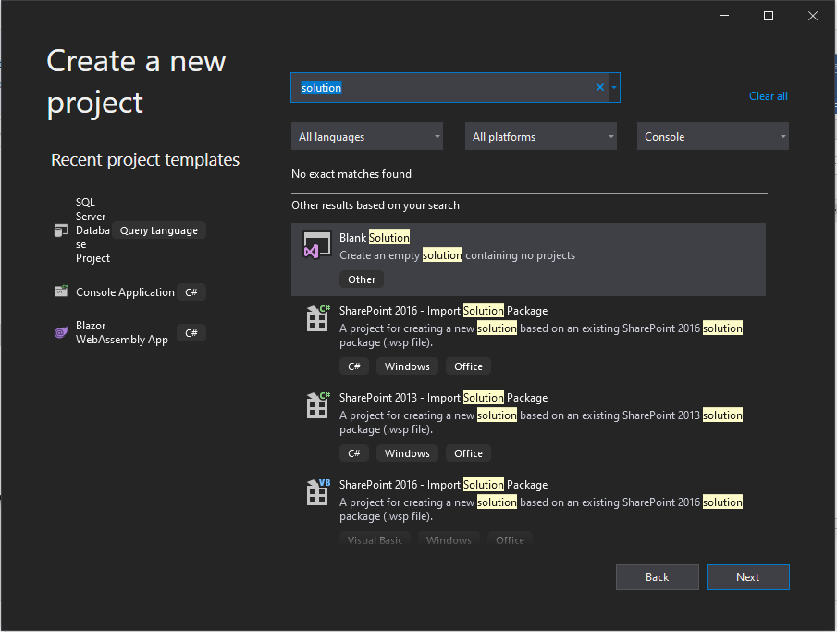

## Give the solution and folder as the folder of the repository

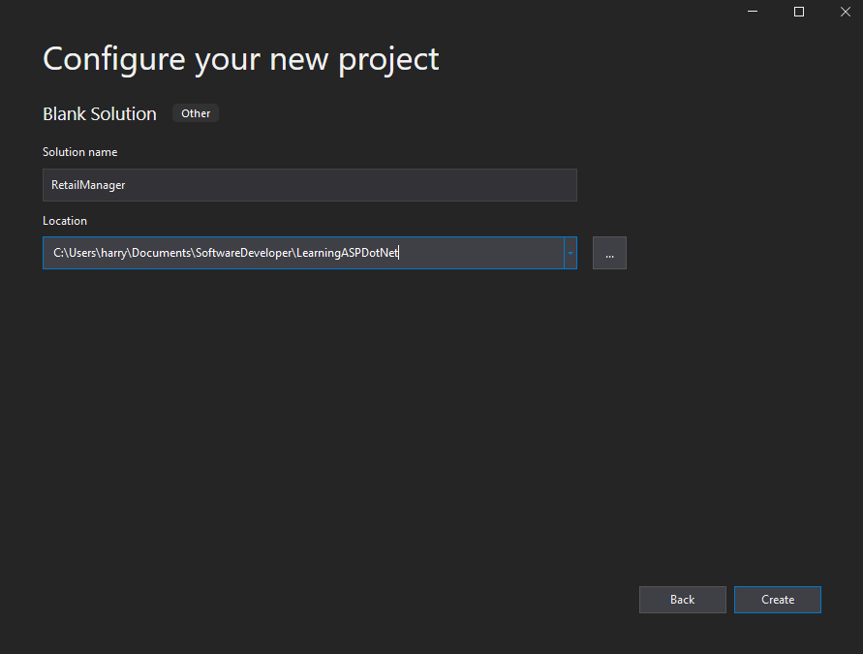

## The solution is created

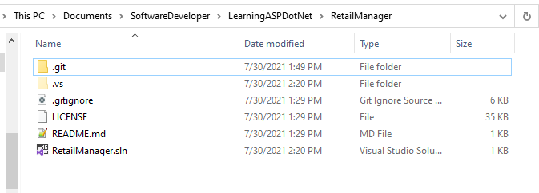

# Create ASP.NET Web Application (.NET Framework) Project

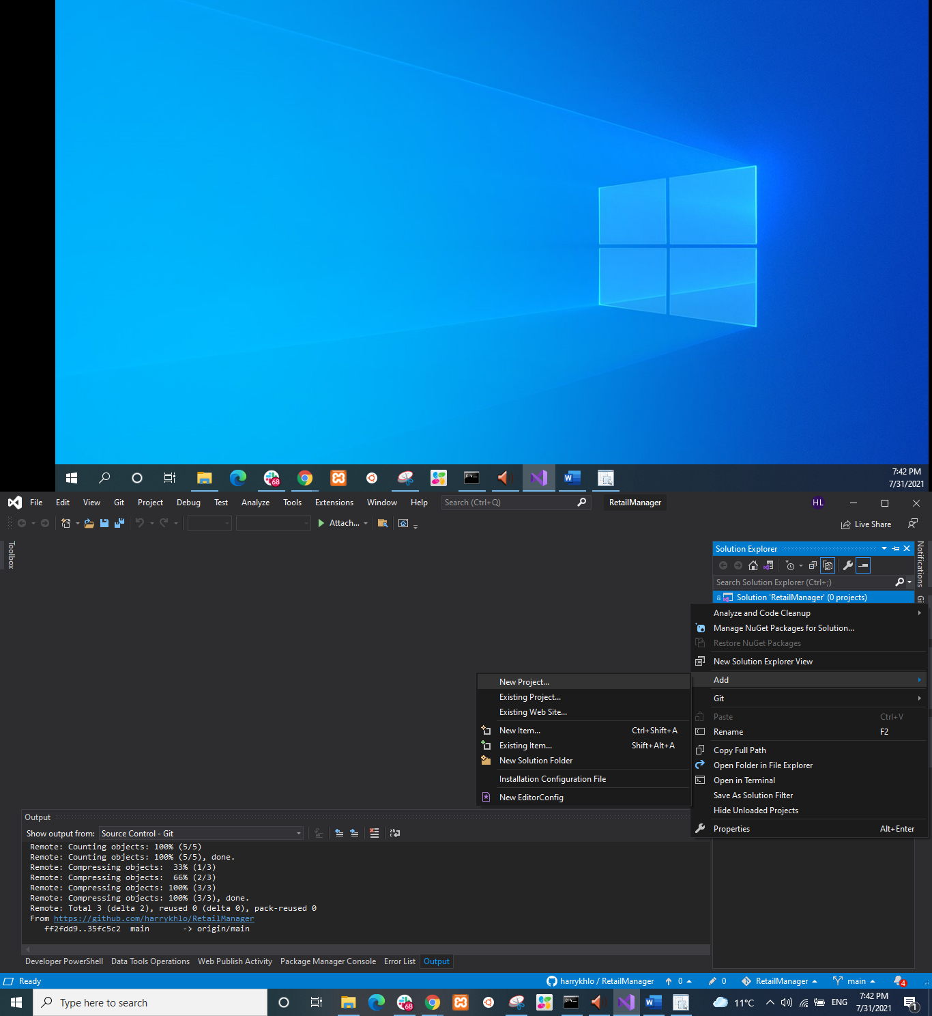

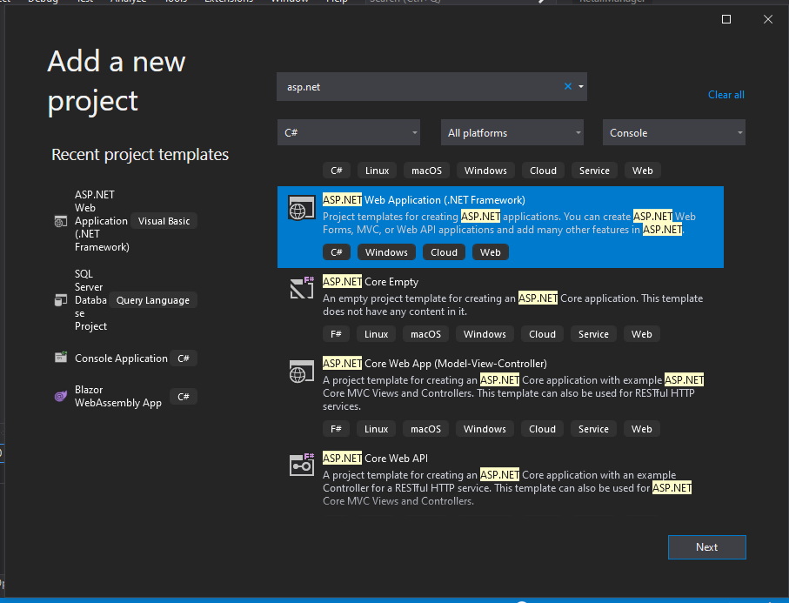

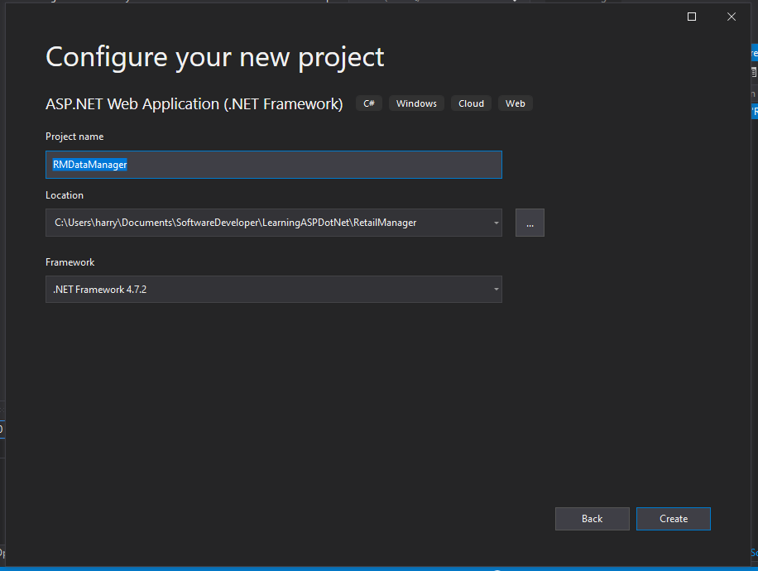

## With individual User Accounts Authentication

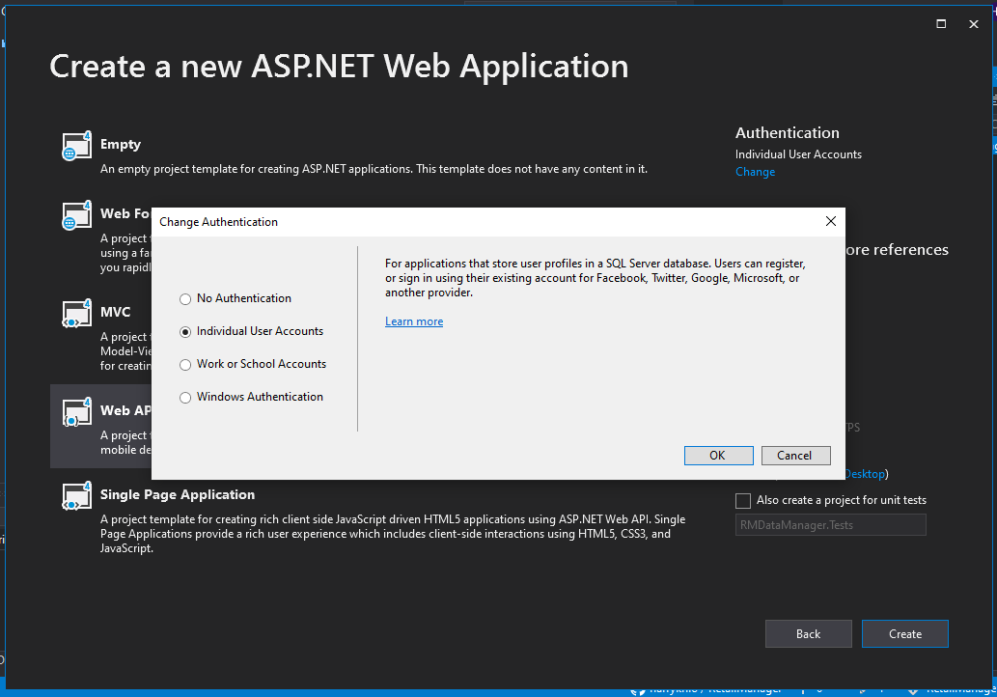

## MVC folders are added to web API project

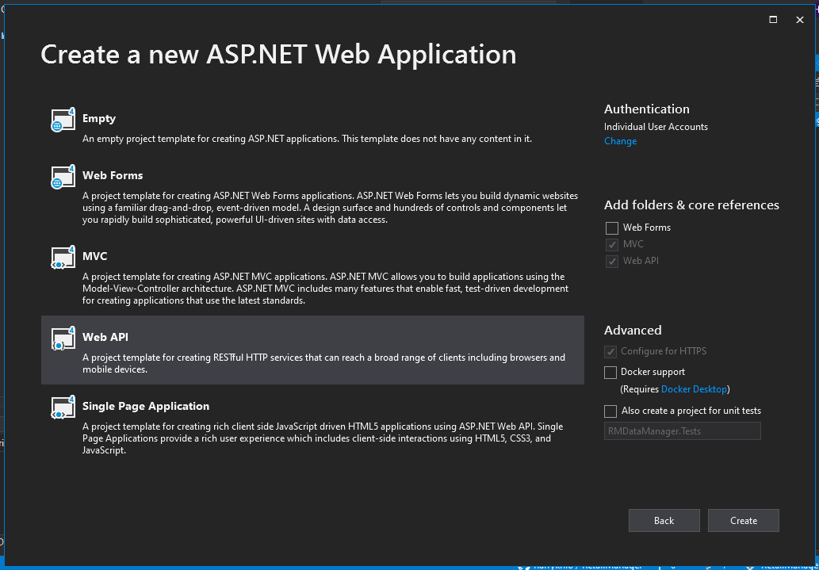

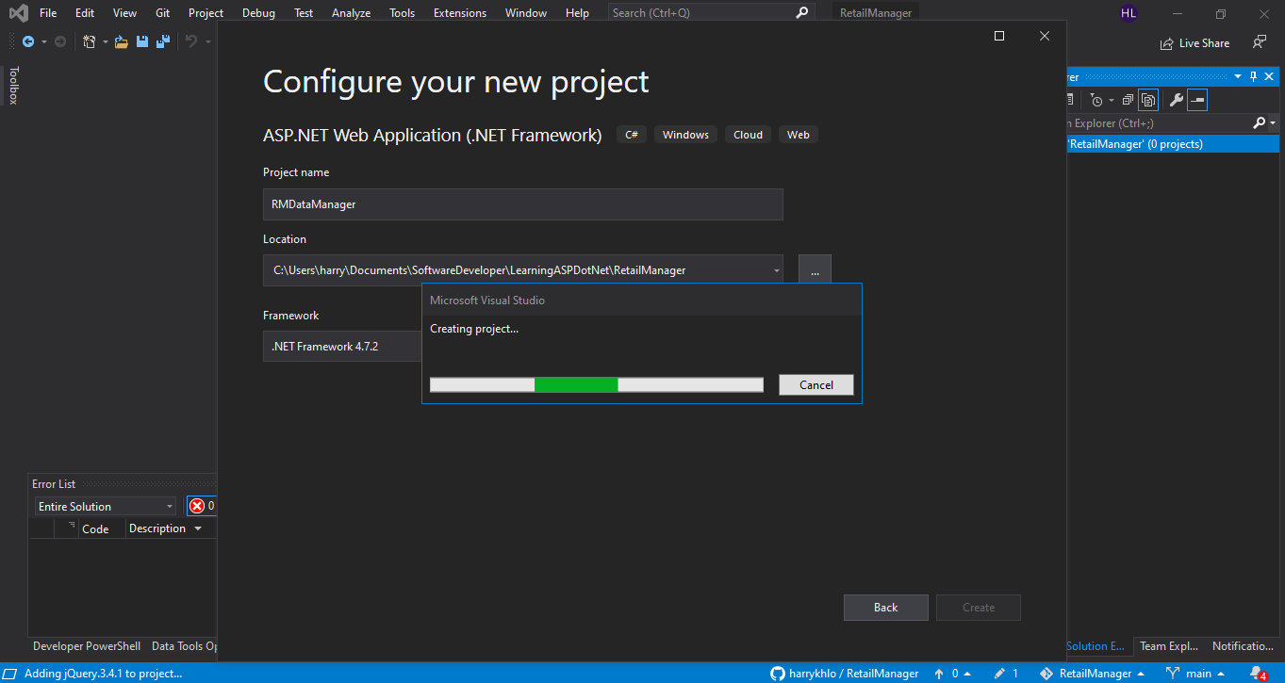

Project is created below

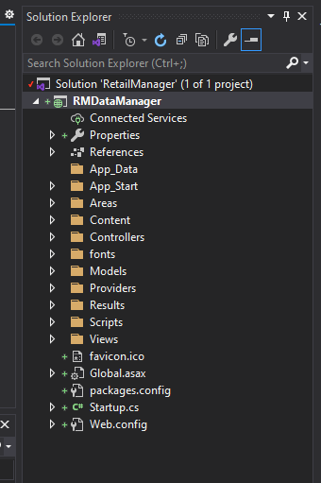

## Updated NuGet except bootstrap

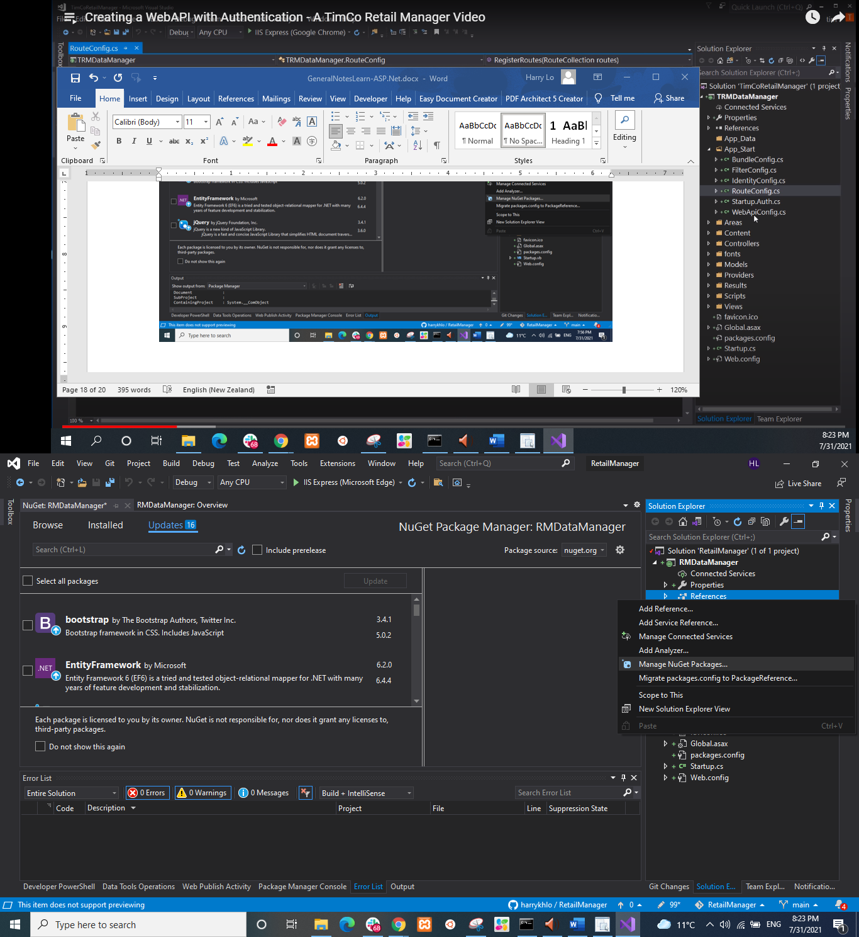

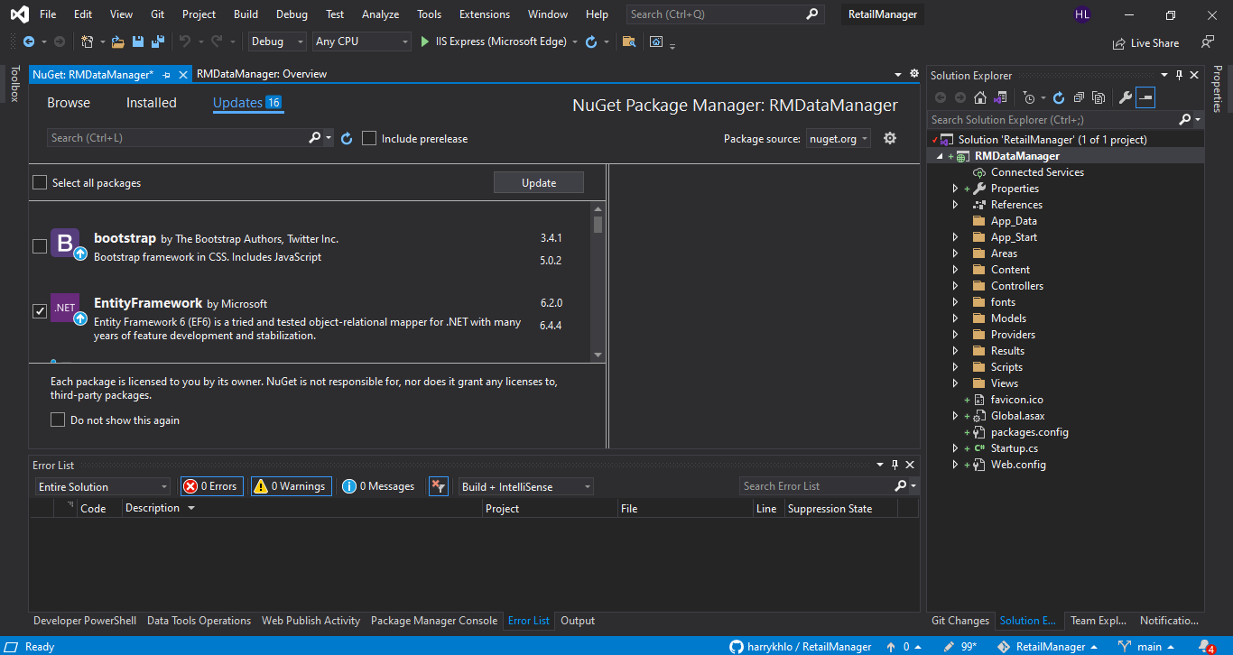

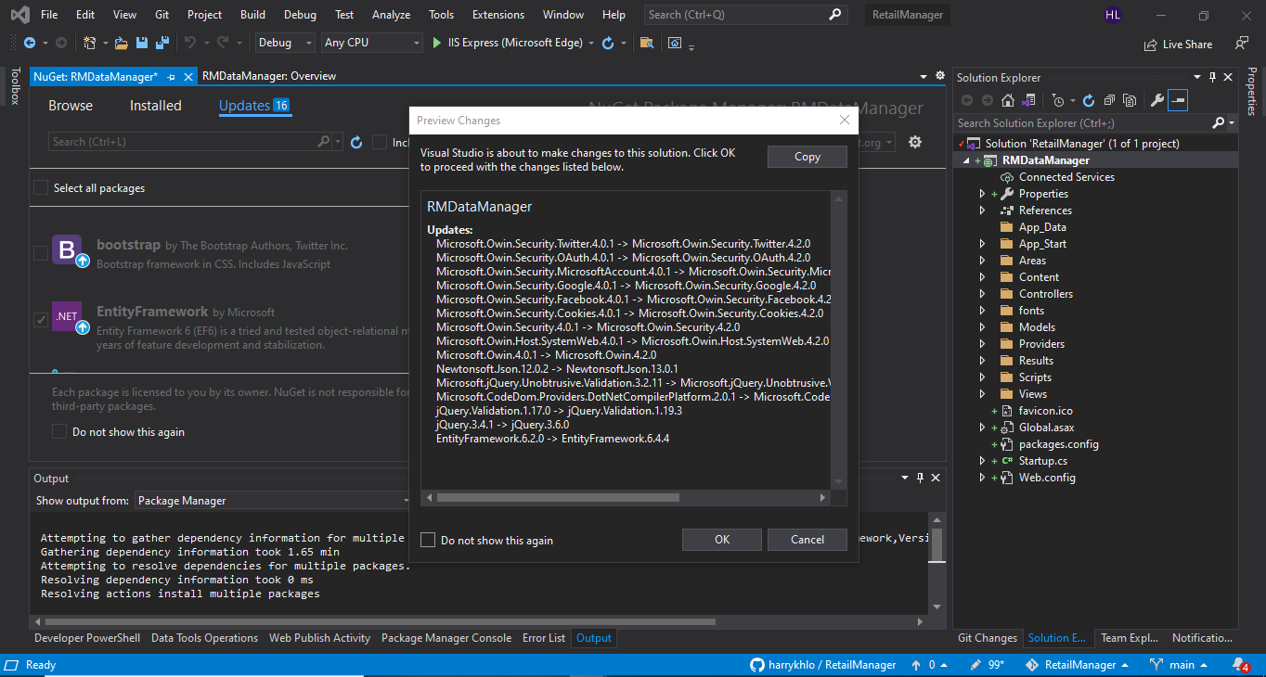

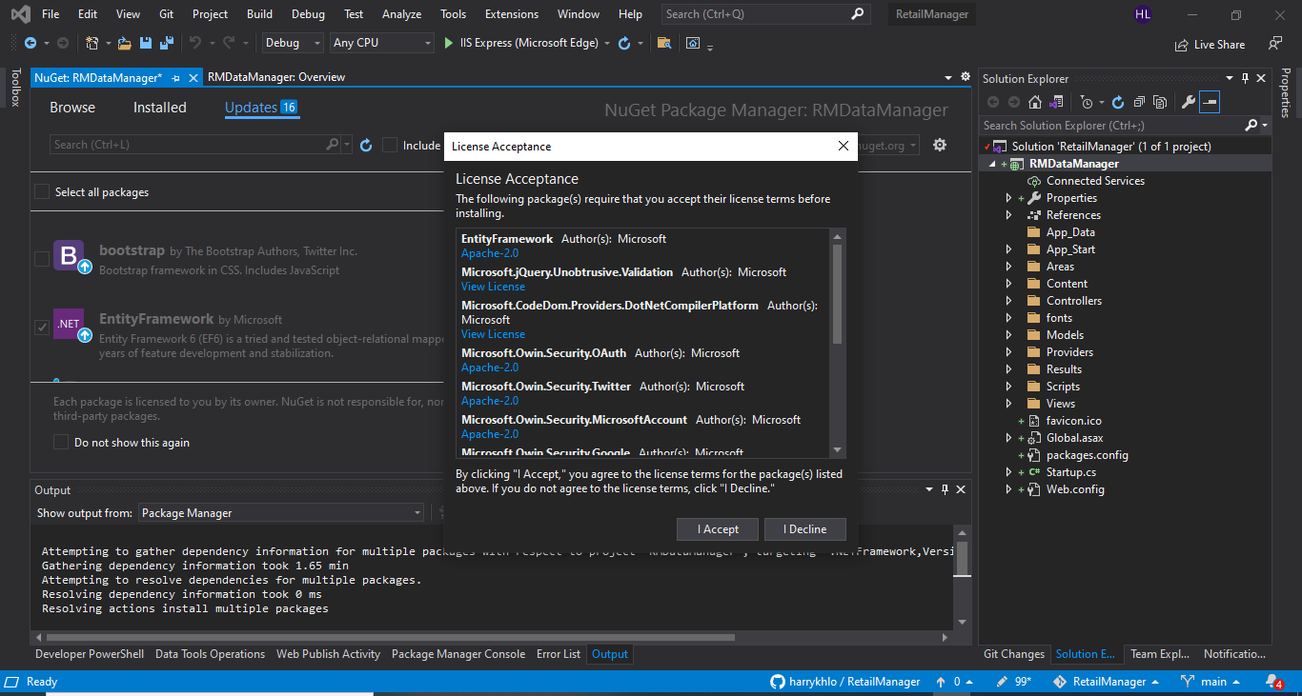

## Route for MVC is at RouteConfig.cs

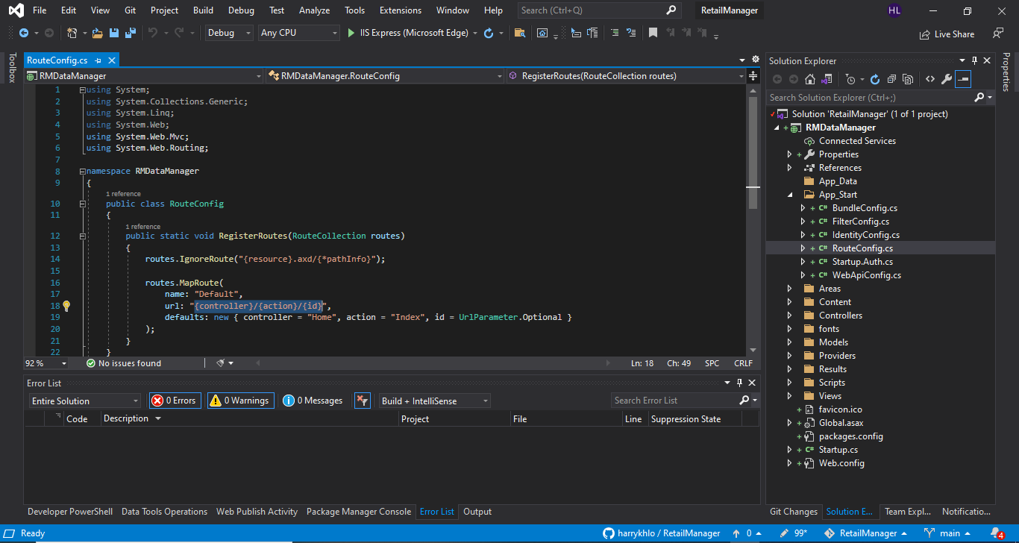

## Route for API is at WebApiConfig.cs

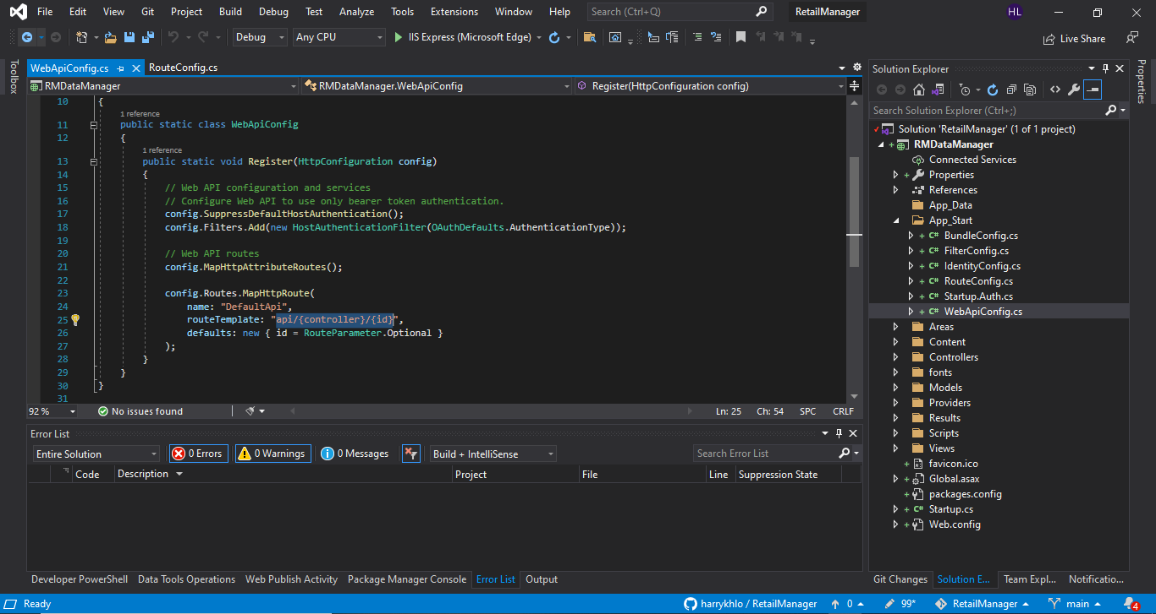

## Configuration for user validation e.g. rules for username and password in IdentiftyConfig.cs

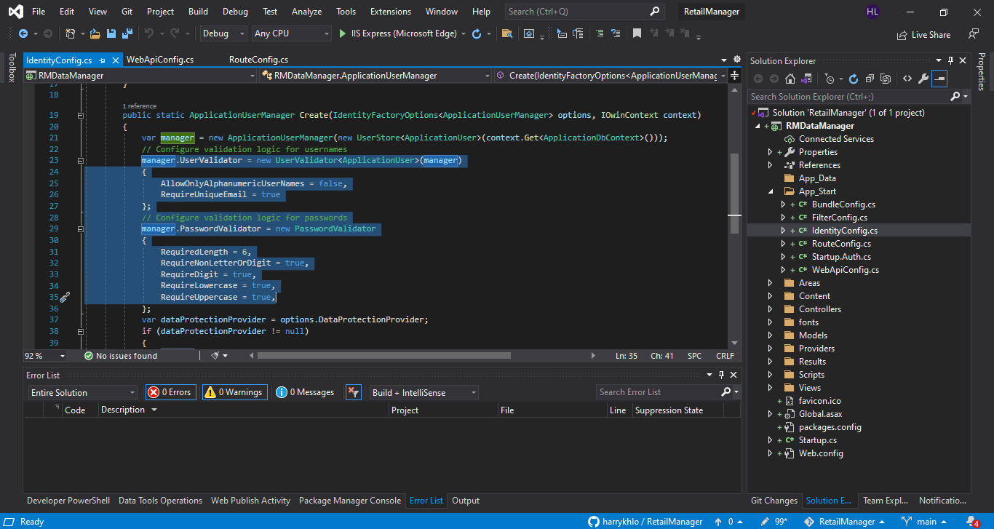

The end point for https://localhost:44375/api/Values is secured by the [Authorize] at the ValuesController.cs below

User who calls this end point has to login

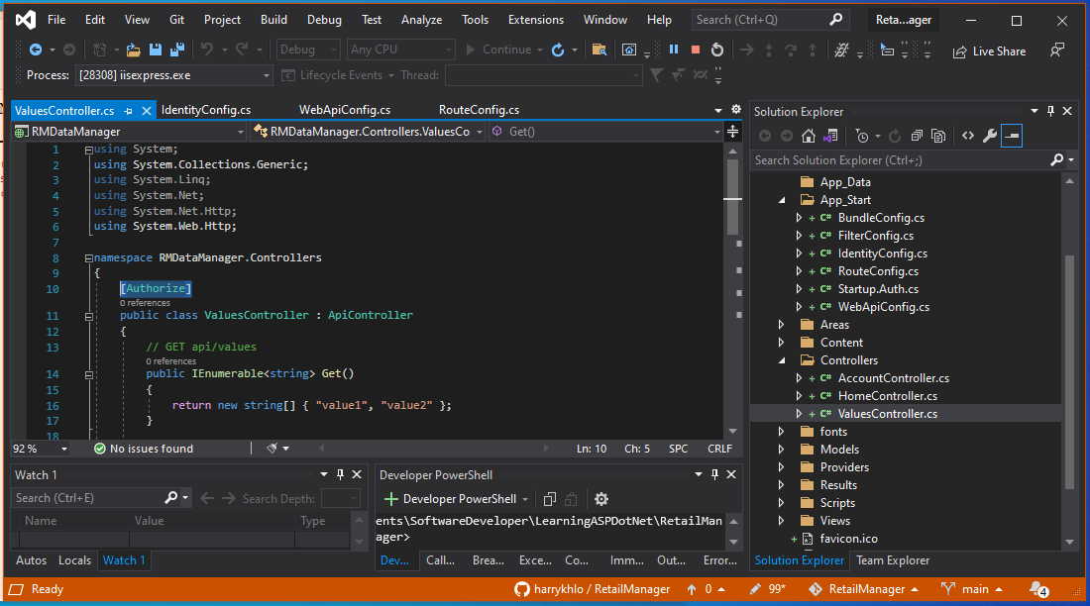

## MVC controller

MVC controller inherited from Controller as screenshot below:

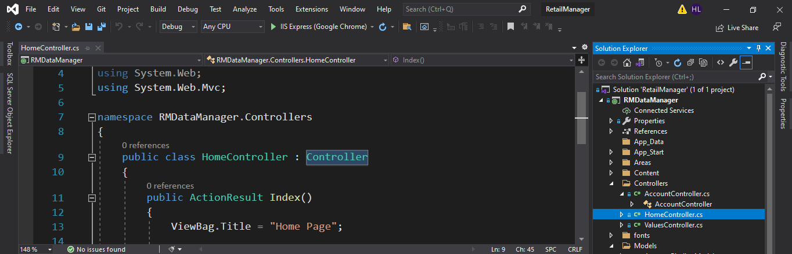

## API controller

API controller inherited from ApiController as screenshot below:

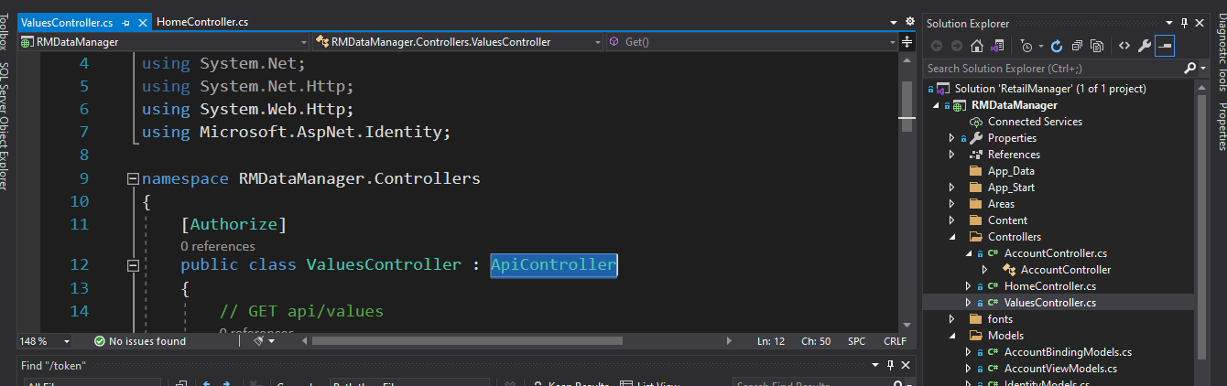

# Run the app and see the API help page

Click run button

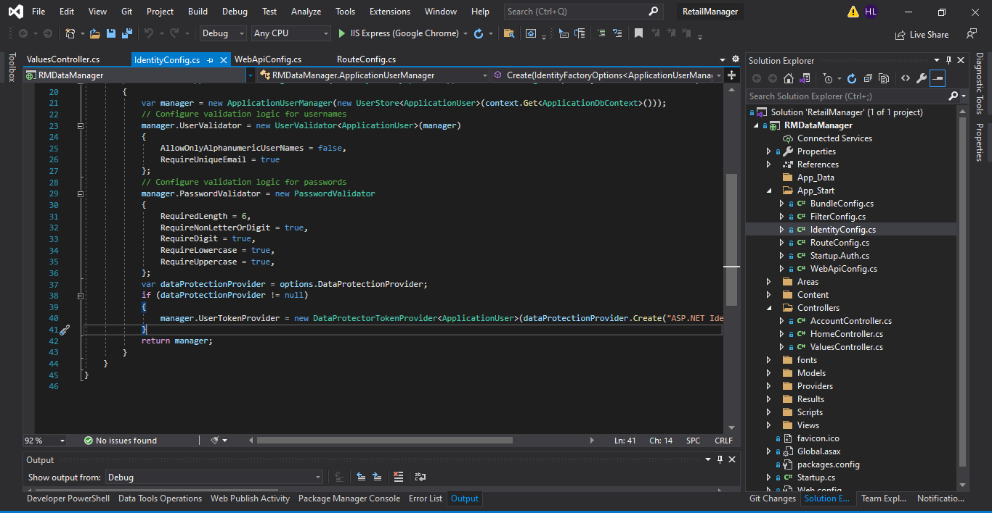

Browser pops up

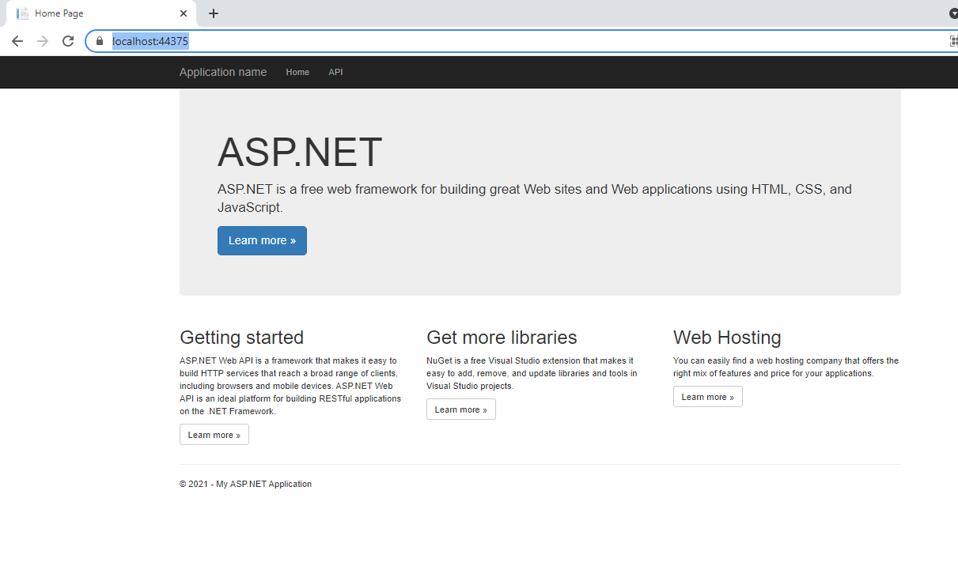

Click API, gives the API help page

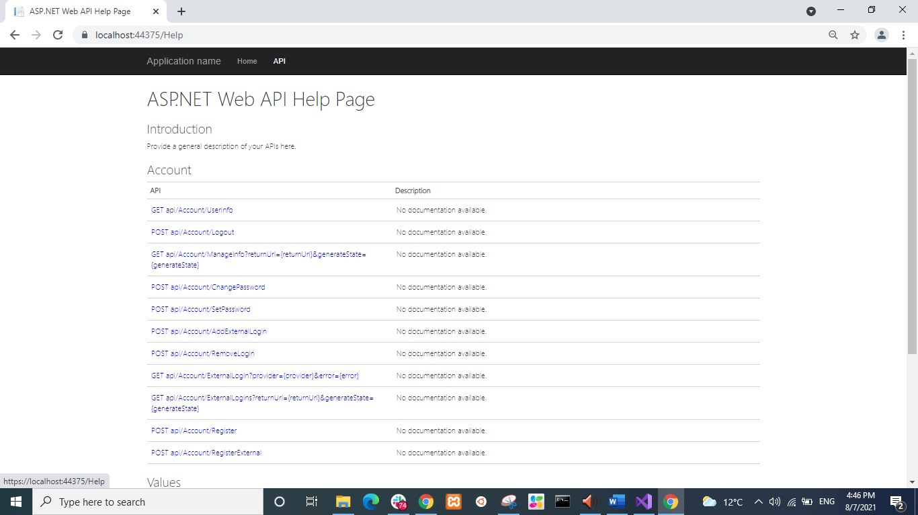

# Register a user with Sample User information

Send post request to the end point for registering a new user

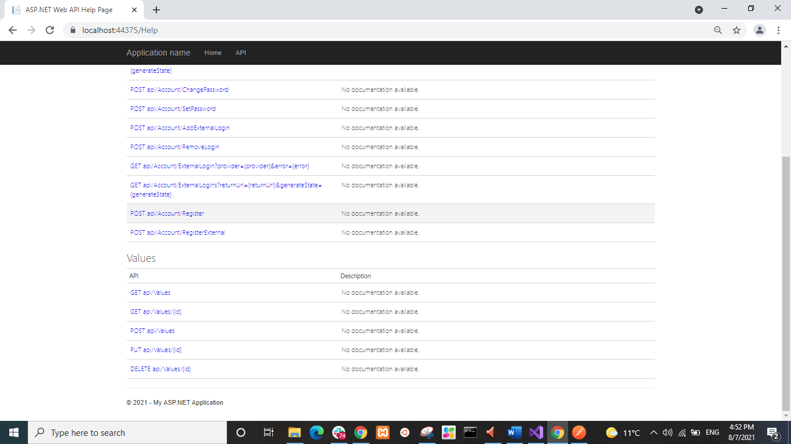

<https://localhost:44375/api/account/register>

The body of the post requests for two users are below:

{

"Email":"email1@email.com",

"Password":"Password1@",

"ConfirmPassword":"Password1@"

}

{

"Email":"email2@email.com",

"Password":"Password1@",

"ConfirmPassword":"Password1@"

}

{

"Email":"email3@email.com",

"Password":"Password1@",

"ConfirmPassword":"Password1@"

}

Sending the post request by using Postman or Advanced REST Client

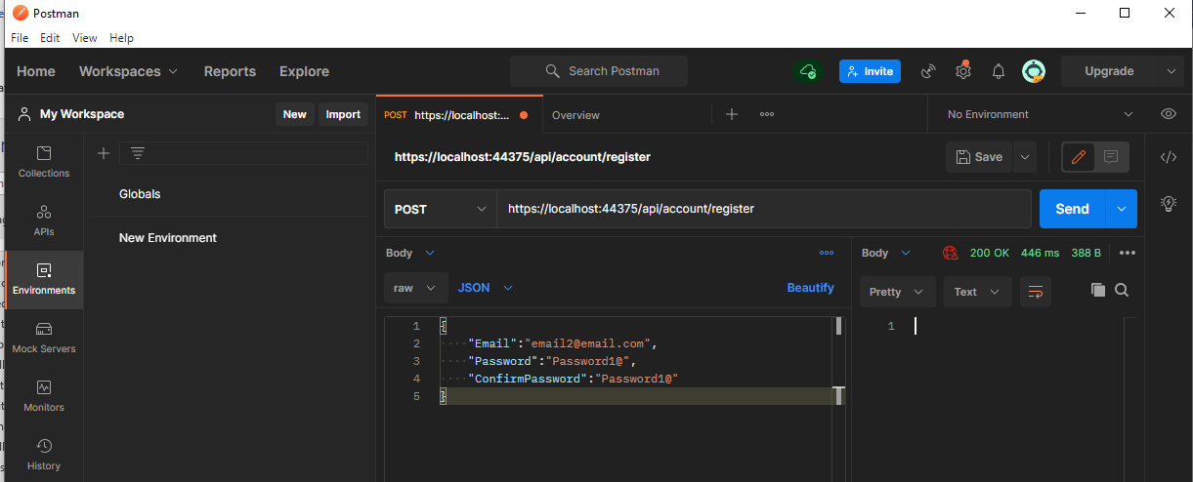

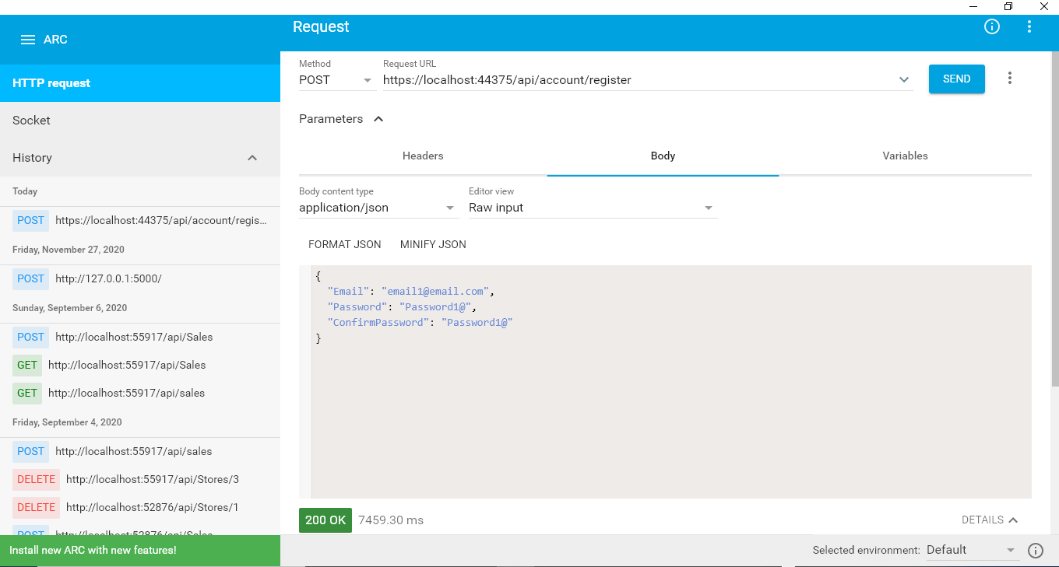

# Get access token

Set a get request to “https://localhost:44375/token” with the grant_type, username and password to the “token” end point as shown below

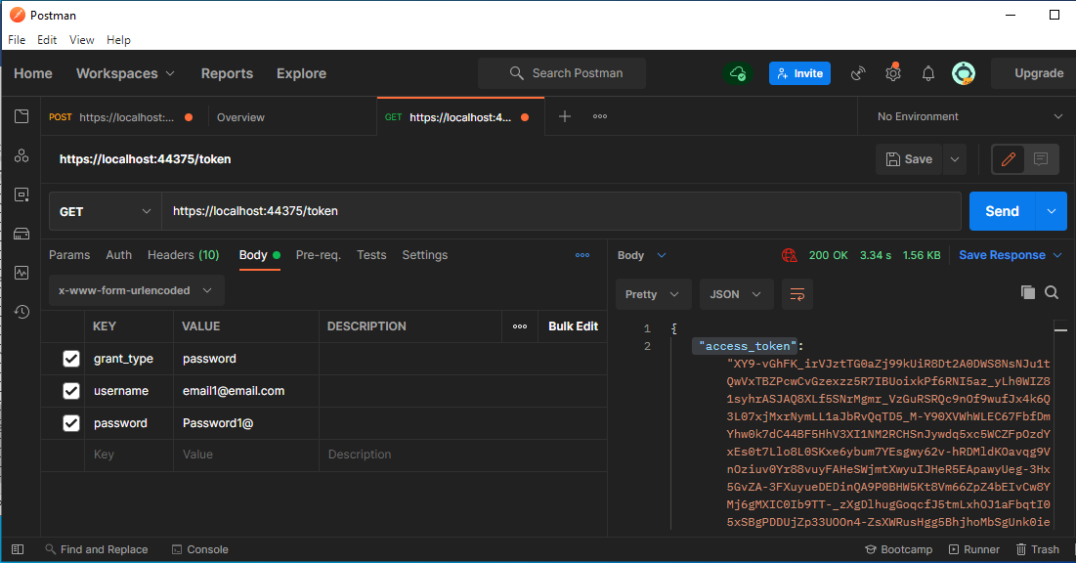

## Question?

How do we know what keys we needed for certain get request e.g. “https://localhost:44375/token”?

### Answer

The path /token is defined in Startup.Auth.cs as shown in the screenshot below :

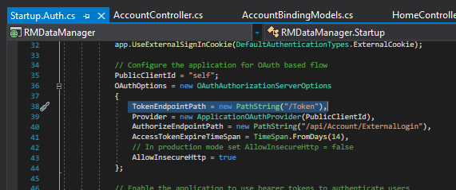

# Get values of the user

## Need to get the token see Section 8

get request to “https://localhost:44375/token” with the grant_type, username and password to the “token” end point will get return data as shown below. The access_token is used for get the values of the user.

{

"access_token": "XY9-vGhFK_irVJztTG0aZj99kUiR8Dt2A0DWS8NsNJu1tQwVxTBZPcwCvGzexzz5R7IBUoixkPf6RNI5az_yLh0WIZ81syhrASJAQ8XLf5SNrMgmr_VzGuRSRQc9nOf9wufJx4k6Q3L07xjMxrNymLL1aJbRvQqTD5_M-Y90XVWhWLEC67FbfDmYhw0k7dC44BF5HhV3XI1NM2RCHSnJywdq5xc5WCZFpOzdYxEs0t7Llo8L0SKxe6ybum7YEsgwy62v-hRDMldKOavqg9VnOziuv0Yr88vuyFAHeSWjmtXwyuIJHeR5EApawyUeg-3Hx5GvZA-3FXuyueDEDinQA9P0BHW5Kt8Vm66ZpZ4bEIvCw8YMj6gMXIC0Ib9TT-_zXgDlhugGoqcfJ5tmLxhOJ1aFbqtI05xSBgPDDUjZp33UOOn4-ZsXWRusHgg5BhjhoMbSgUnk0ieoKYMFoTZaER_iSHU-gSToeLpTwumJMsY",

"token_type": "bearer",

"expires_in": 1209599,

"userName": "email1@email.com",

".issued": "Sat, 07 Aug 2021 05:18:53 GMT",

".expires": "Sat, 21 Aug 2021 05:18:53 GMT"

}

## Get values of the user by using the token

End point to: <https://localhost:44375/api/values>

Header key: Authorization

Header Value: Bearer XY9-vGhFK_irVJztTG0aZj99kUiR8Dt2A0DWS8NsNJu1tQwVxTBZPcwCvGzexzz5R7IBUoixkPf6RNI5az_yLh0WIZ81syhrASJAQ8XLf5SNrMgmr_VzGuRSRQc9nOf9wufJx4k6Q3L07xjMxrNymLL1aJbRvQqTD5_M-Y90XVWhWLEC67FbfDmYhw0k7dC44BF5HhV3XI1NM2RCHSnJywdq5xc5WCZFpOzdYxEs0t7Llo8L0SKxe6ybum7YEsgwy62v-hRDMldKOavqg9VnOziuv0Yr88vuyFAHeSWjmtXwyuIJHeR5EApawyUeg-3Hx5GvZA-3FXuyueDEDinQA9P0BHW5Kt8Vm66ZpZ4bEIvCw8YMj6gMXIC0Ib9TT-_zXgDlhugGoqcfJ5tmLxhOJ1aFbqtI05xSBgPDDUjZp33UOOn4-ZsXWRusHgg5BhjhoMbSgUnk0ieoKYMFoTZaER_iSHU-gSToeLpTwumJMsY

(i.e. Header Value is Bearer <<Token>>)

The values for the user with the token are got as below:

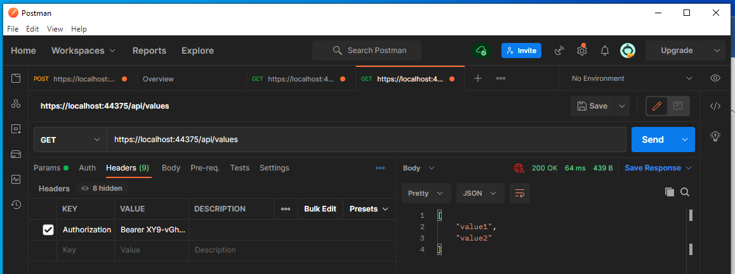

# Location of user data stored

A database is automatically built in the visual studio when the api with the authentication of individual users is created.

The database is shown as below:

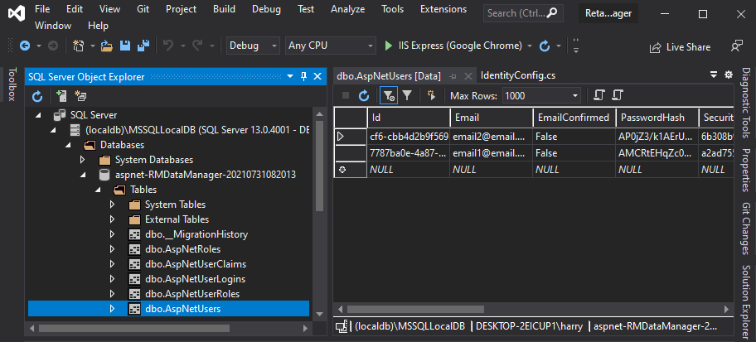

# Add userId obtained from the get request https://localhost:44375/api/values

The get request function is in ValuesController.cs which is inherited from ApiController as shown below

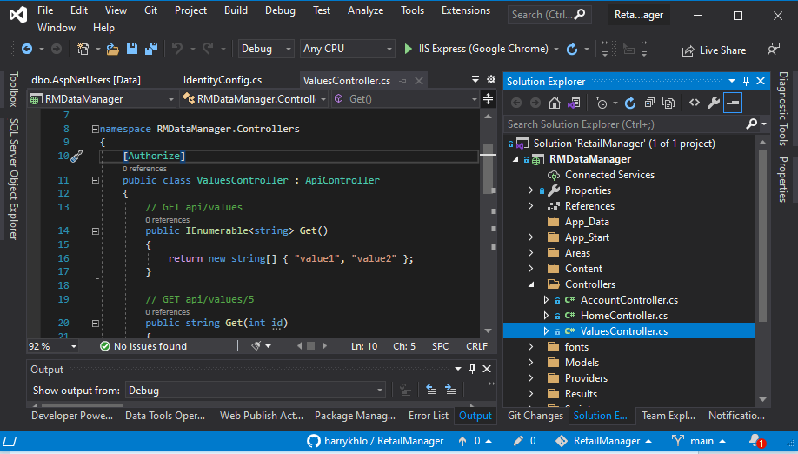

## Add “using Microsoft.AspNet.Identity;”

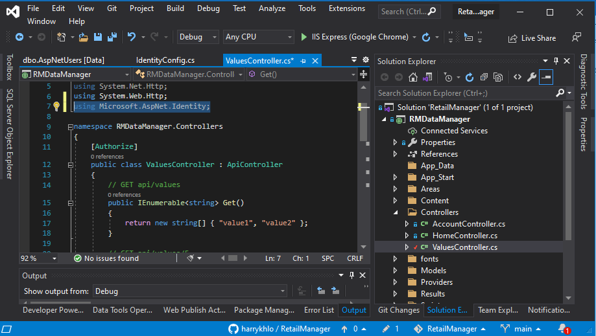

## Get and assign userId in the get function

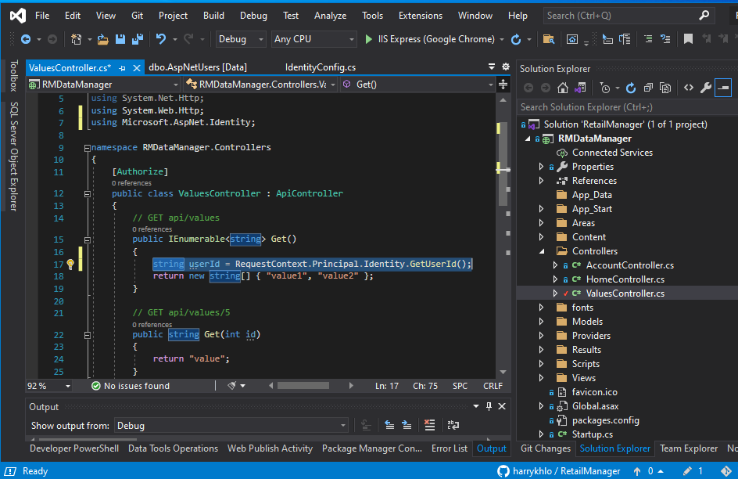

## Return the userId

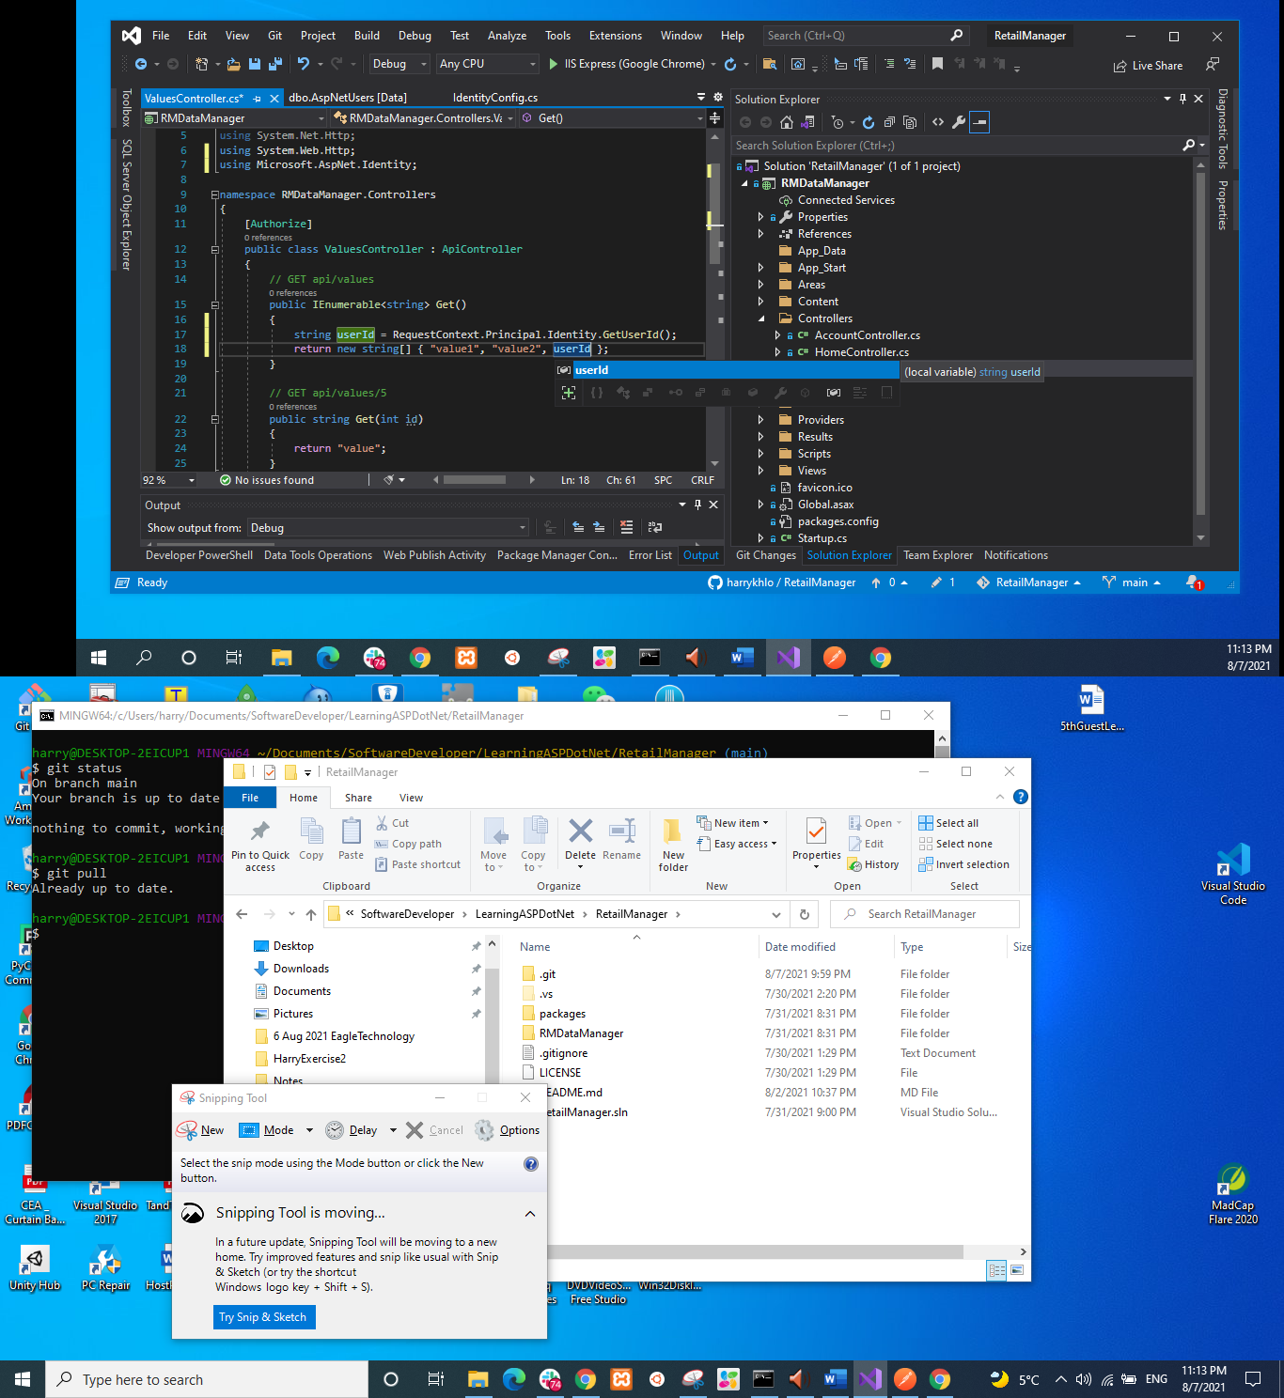

## Tested the end point with Postman returning the userId below

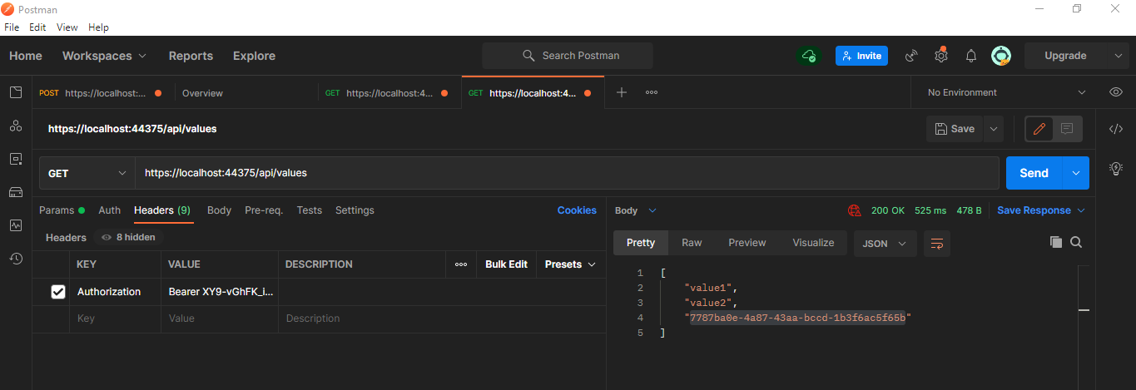

# Difference between API controller and MVC controller

API controller is inherited from ApiController (e.g. ValueController below)

MVC controller is inherited from Controller (e.g. HomeController below)

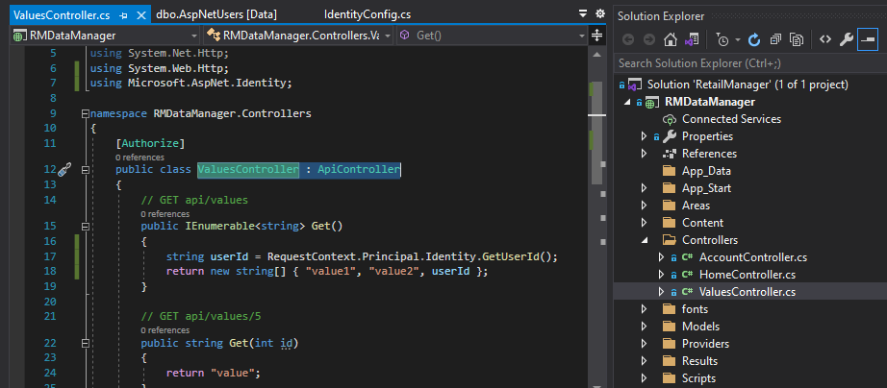

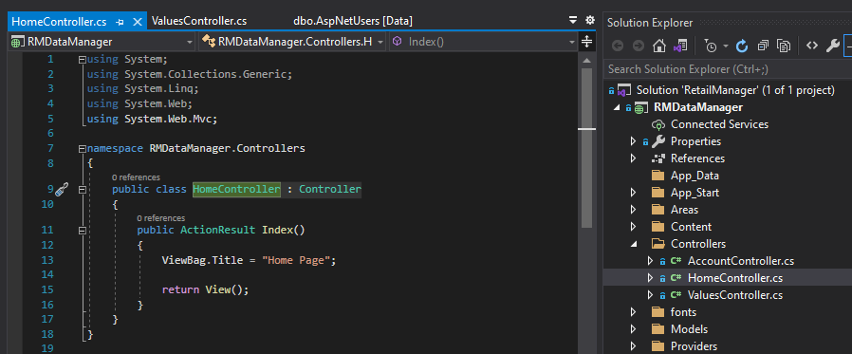

# Configuring Swagger WebAPI

## Add swagger into the WebApi

Right click References -> Magnage NuGet Packages …

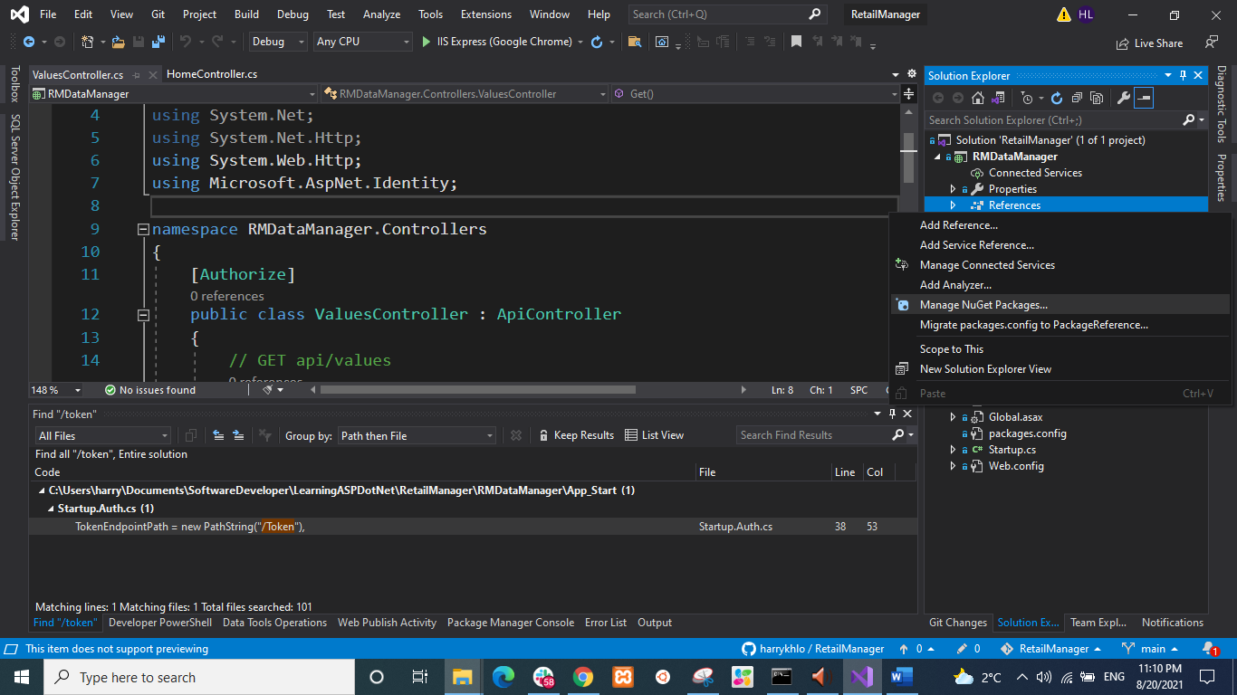

Browse ‘swashbuckle’

‘swashbuckle’ is a package for implementing swagger

See screenshot below:

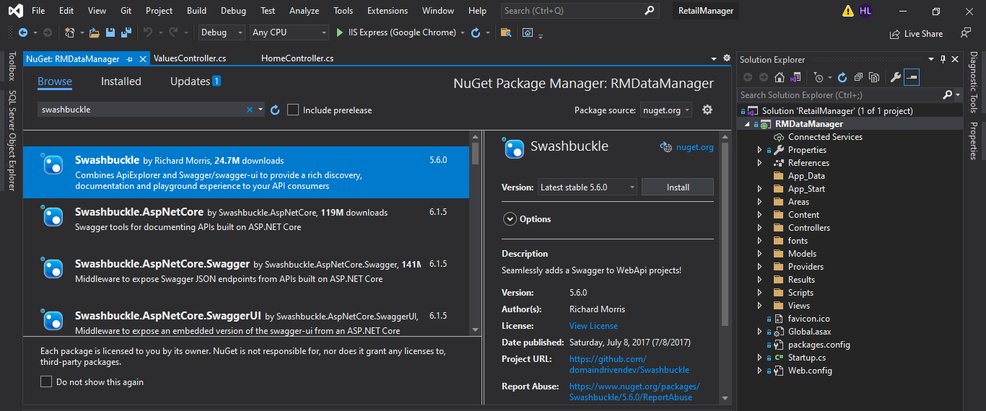

install ‘swashbuckle’

Pop up a preview changes window

Click OK

See screenshot below:

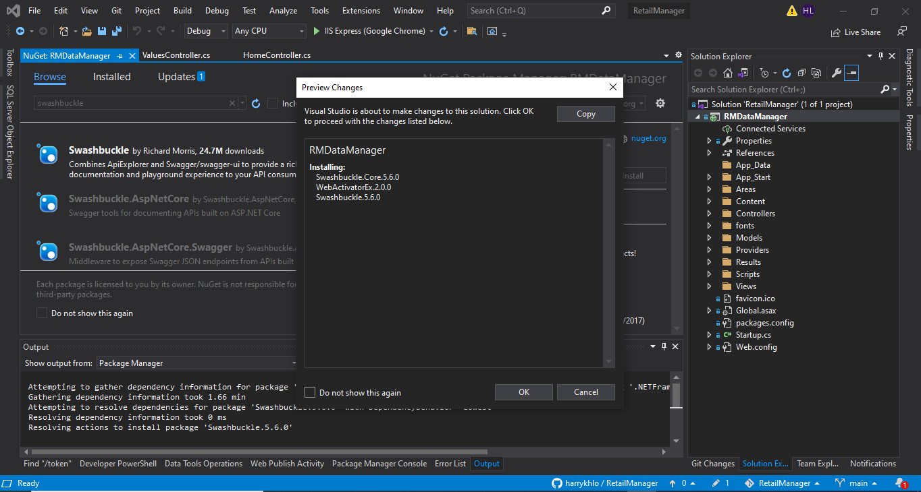

‘swashbuckle’ is installed as screenshot below:

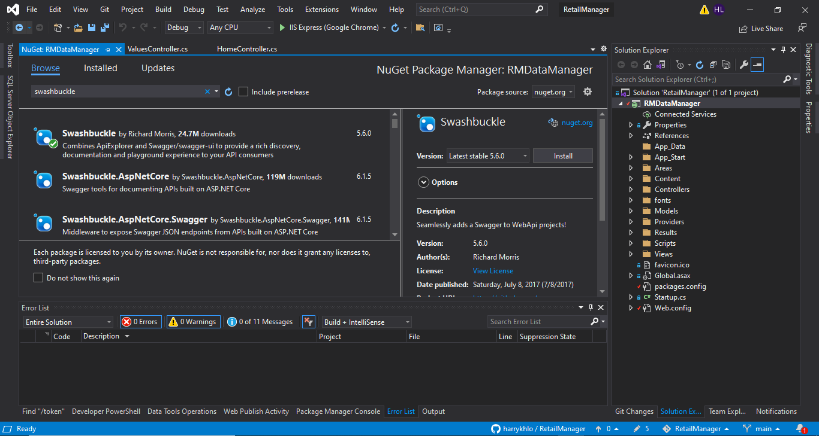

Check for update packages

Update all packages except bootstrap

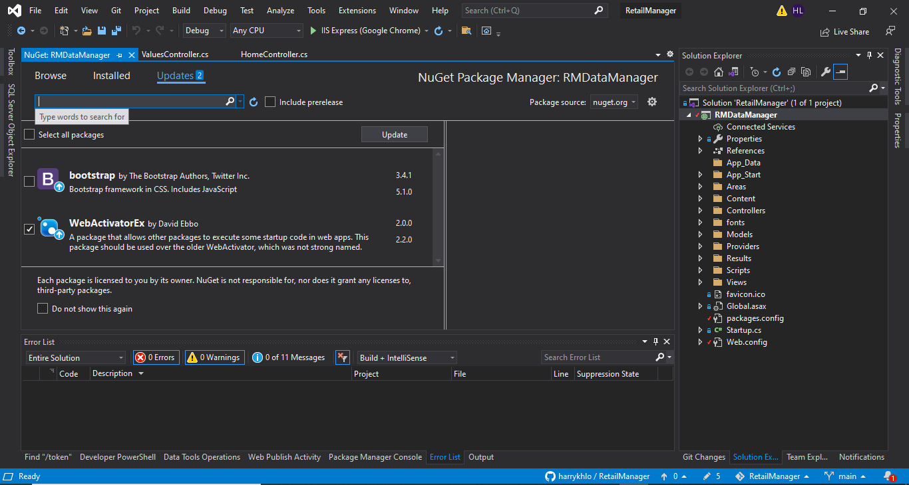

Pop up a preview changes window

Click OK

See screenshot below:

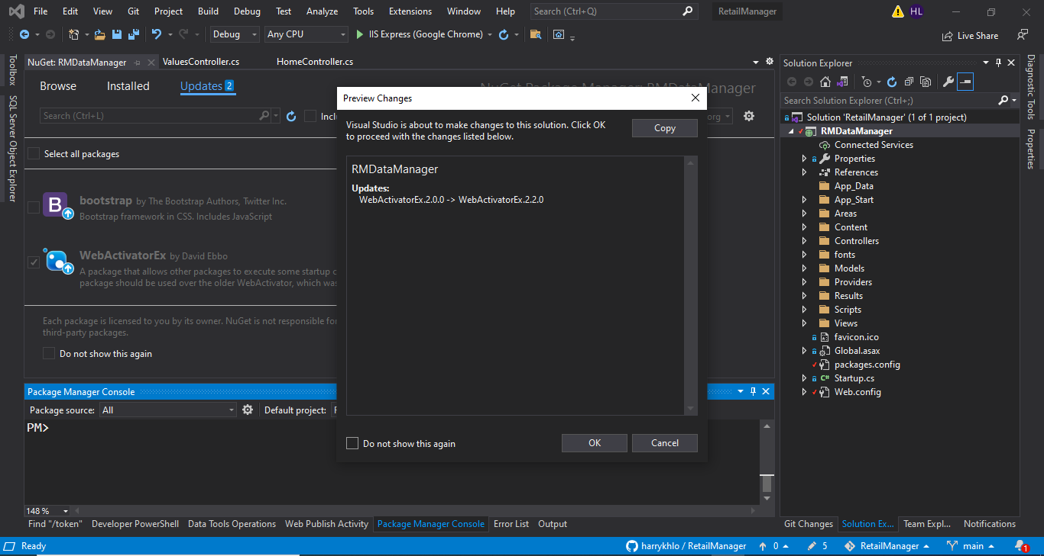

## Browse swagger WebApi

Run the project

By click > IIS Express(Google Chrome)

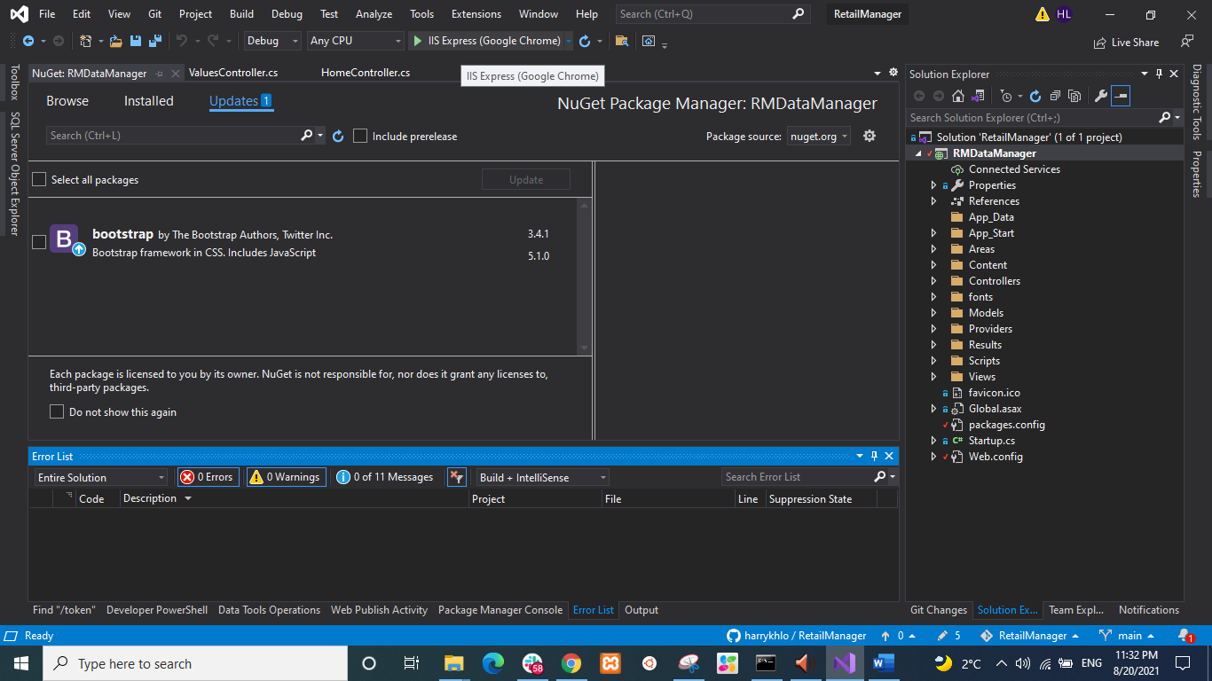

Browse https://localhost:44375/swagger

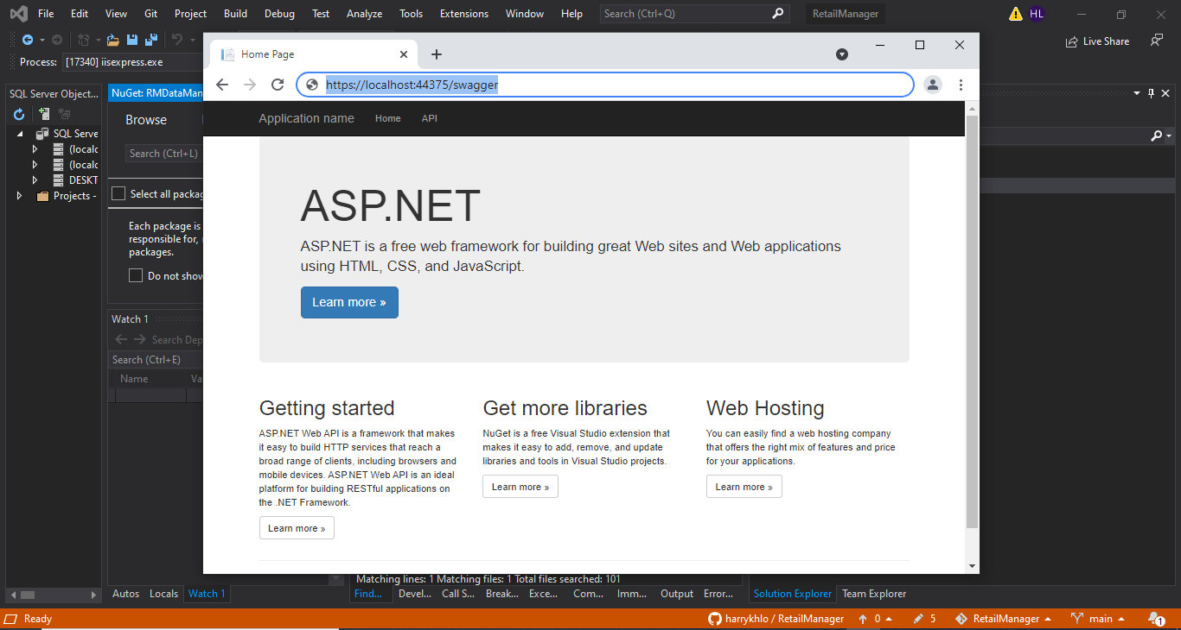

Will be redirected to https://localhost:44375/swagger/ui/index#/

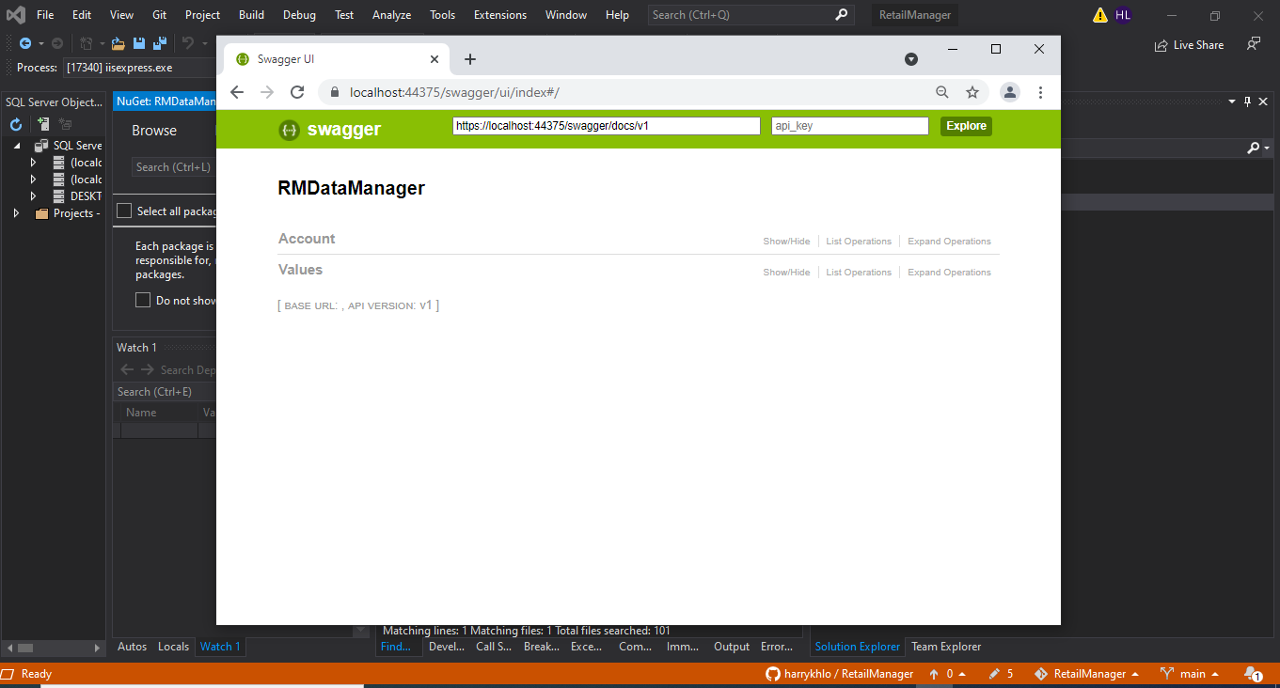

There is https://localhost:44375/swagger/ui/index#/Account as below

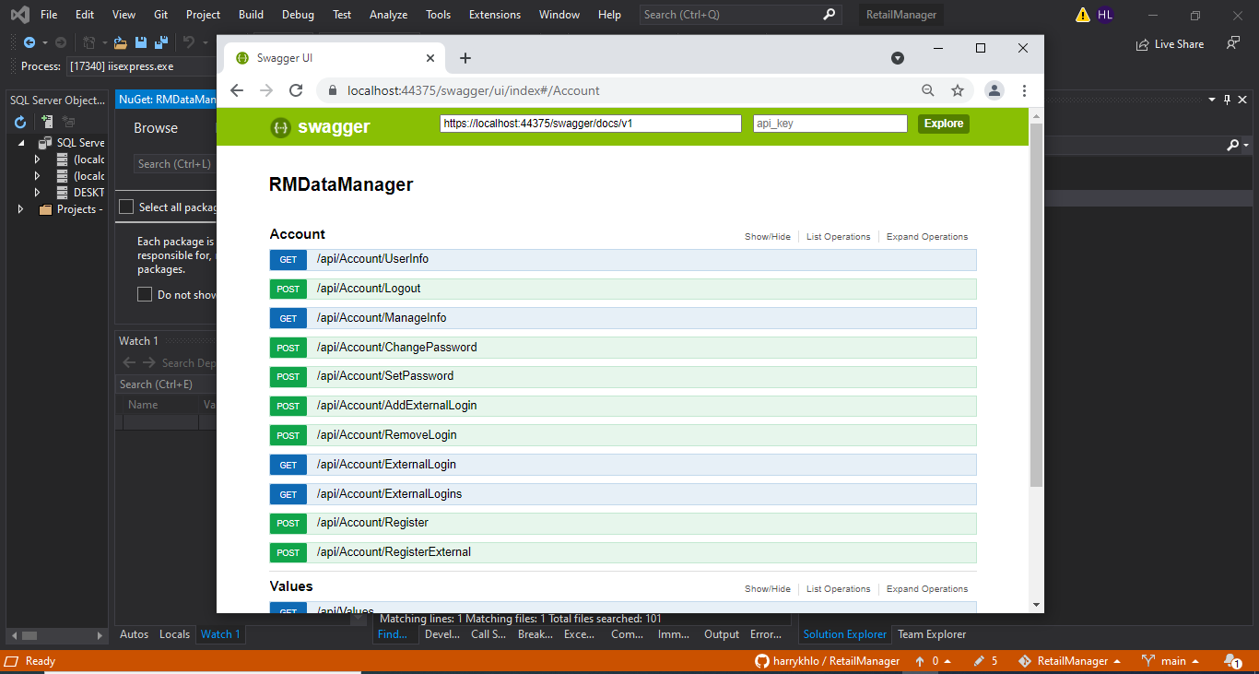

There is https://localhost:44375/swagger/ui/index#/Values as below

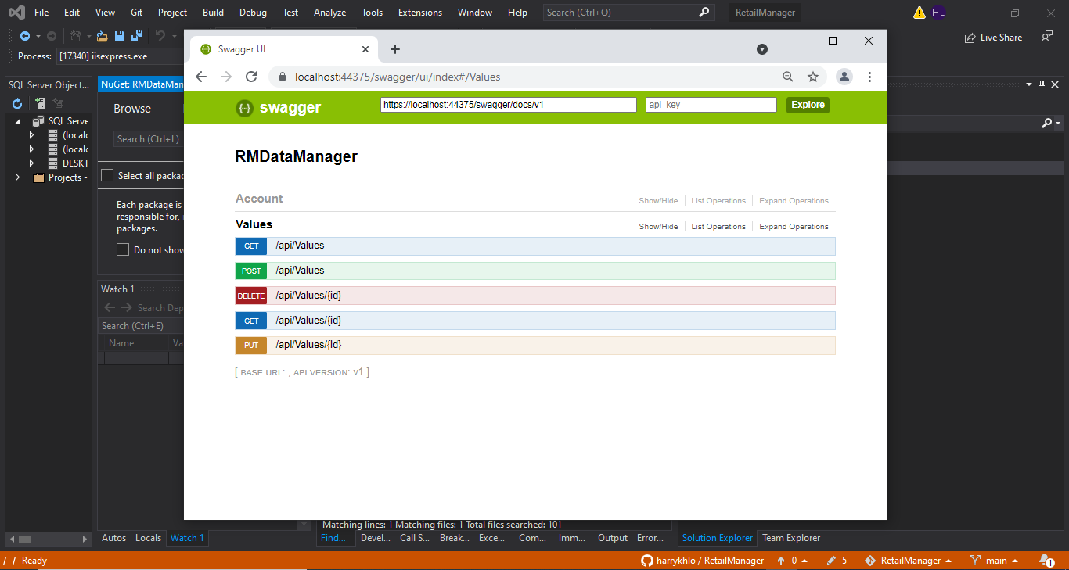

## Configuring Swagger in SwaggerConfig.cs

Configuring Swagger in App_Start/SwaggerConfig.cs under GlobalConfiguration.Configuration as shown below:

(Note: uncomment and / or change the required properties under the GlobalConfiguration.Configuration)

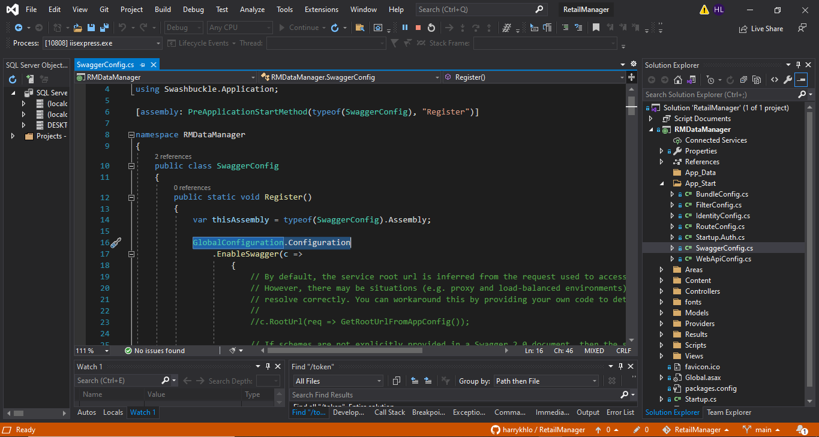

### Configuring Swagger, example: Change the display name of the api to “Retail Manager API - version 1” as 2 screenshots below :

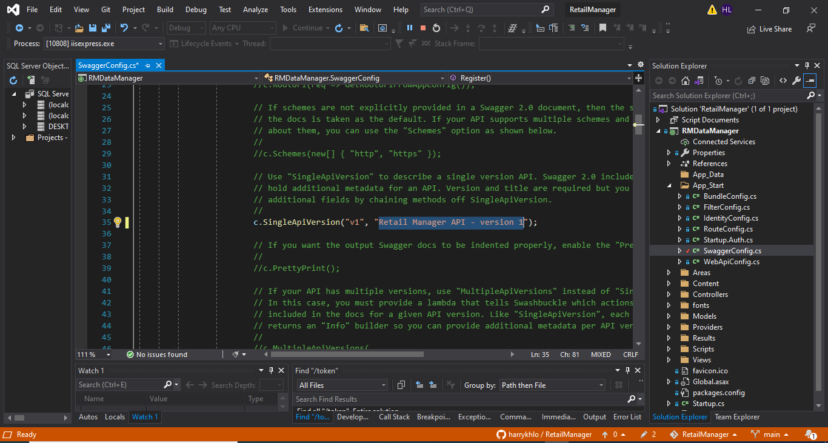

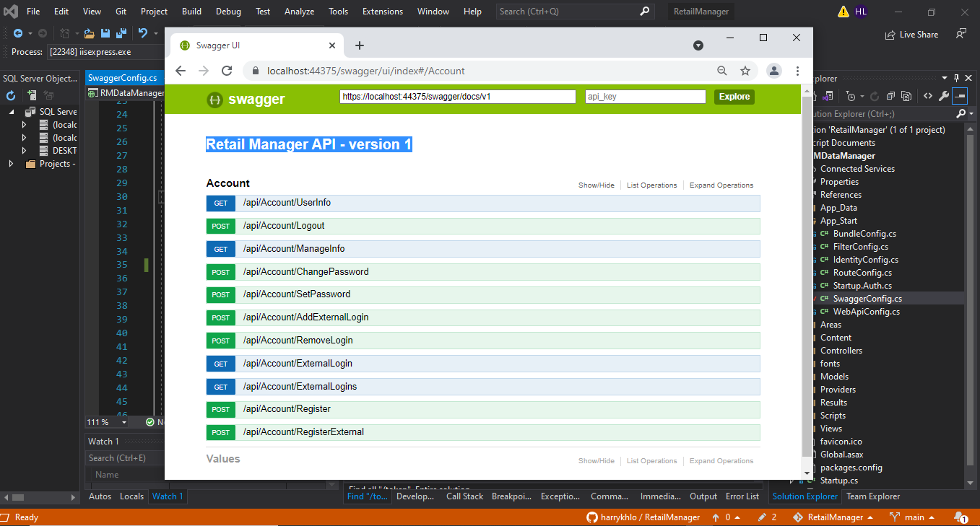

### Configuring Swagger, example: enable PrettyPrint() as below:

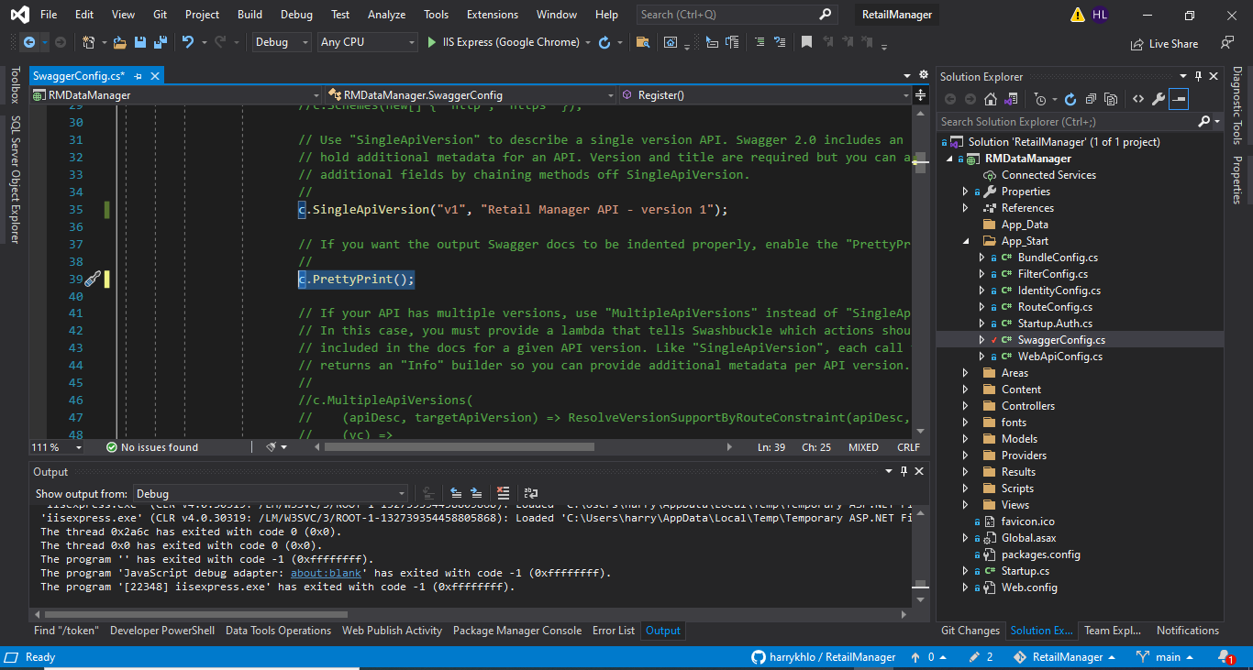

### Configuring Swagger, example: enable DescribeAllEnumsAsStrings() as below:

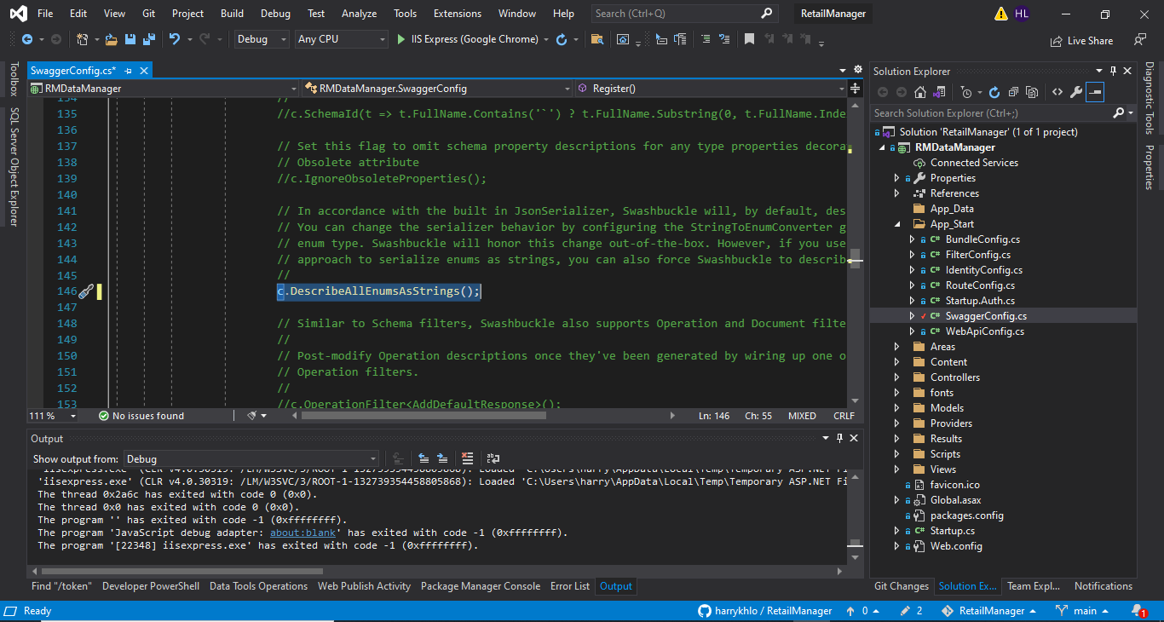

### Configuring Swagger, example: change the title on the tab as 2 screenshots below :

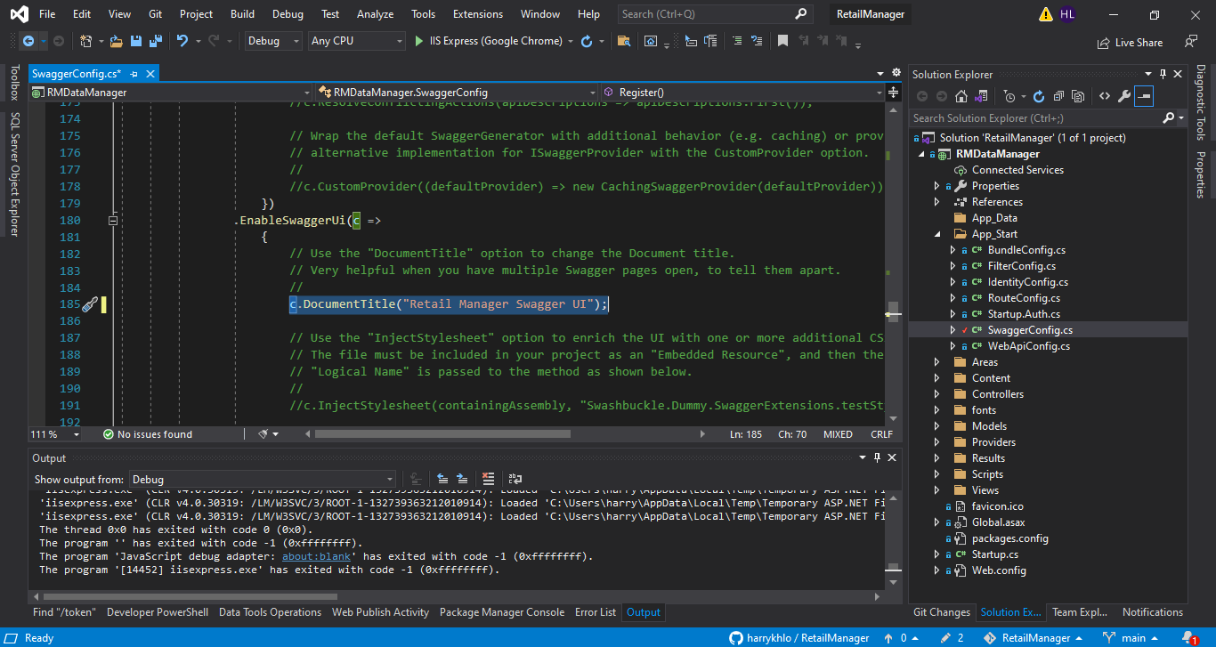

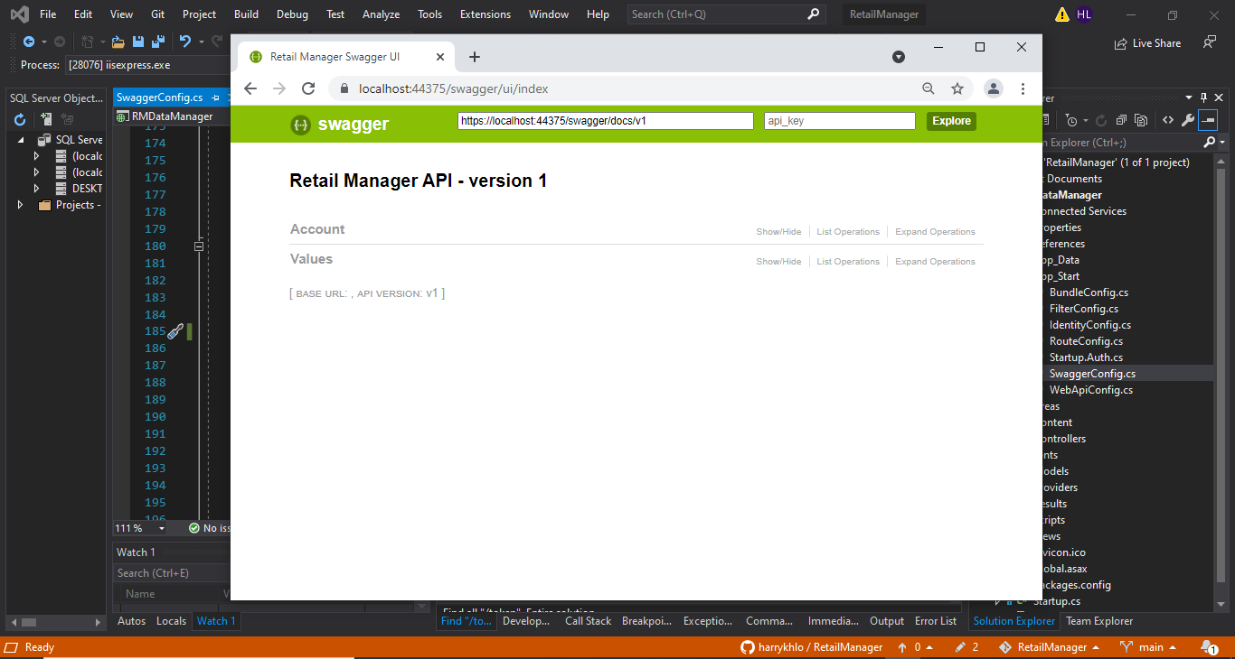

## Make token endpoint available in Swagger

End point for making the Get request to <https://localhost:44375/token> for getting the token of specific user

### Add a new class “AuthTokenOperation.cs” in App_Start

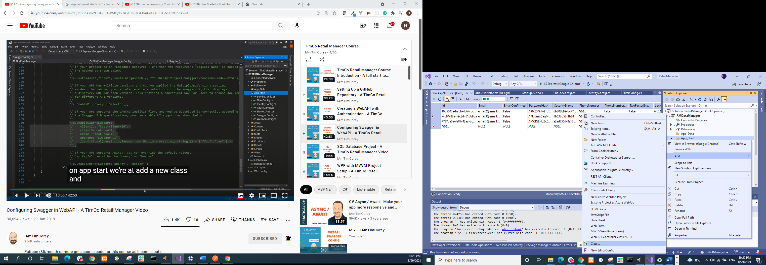

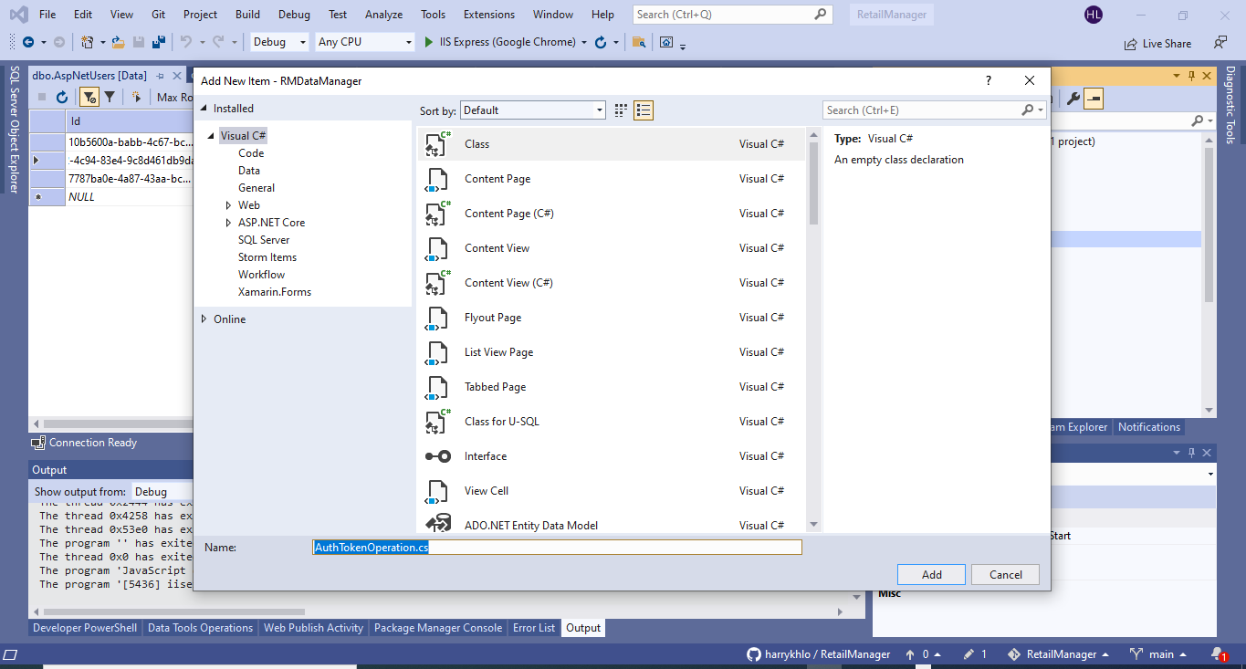

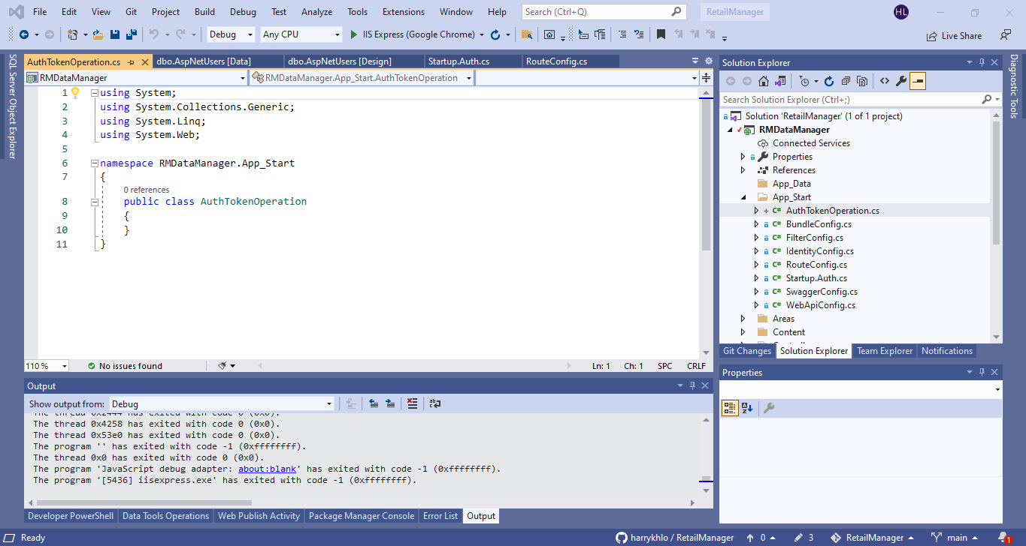

### Inherited & implemented interface “IDocumentFilter” & added “using Swashbuckle.Swagger;”

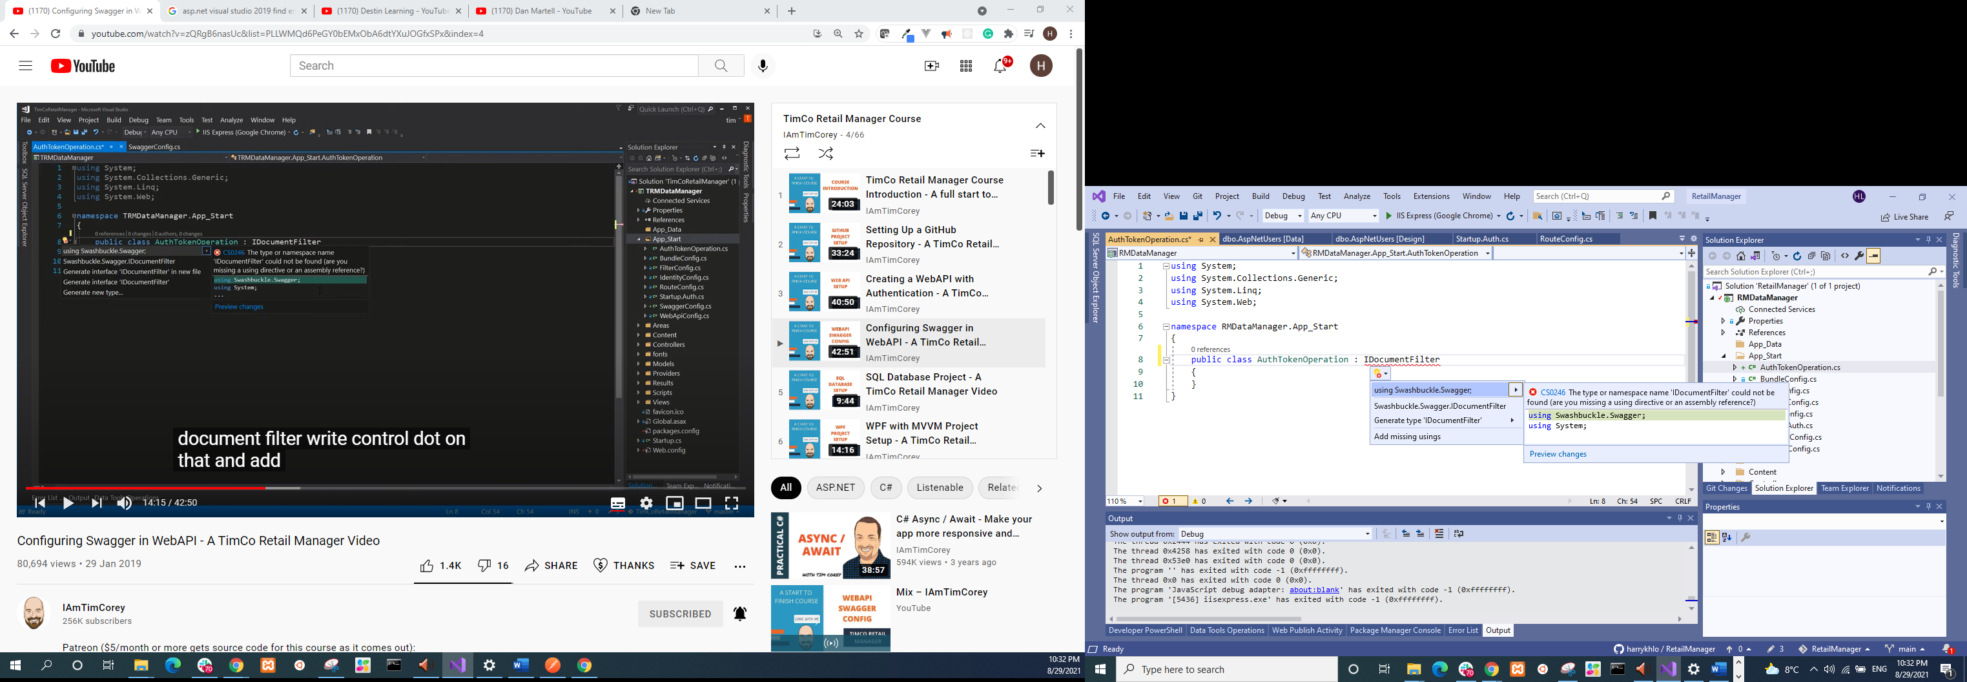

Implement the interface “IDocumentFilter”

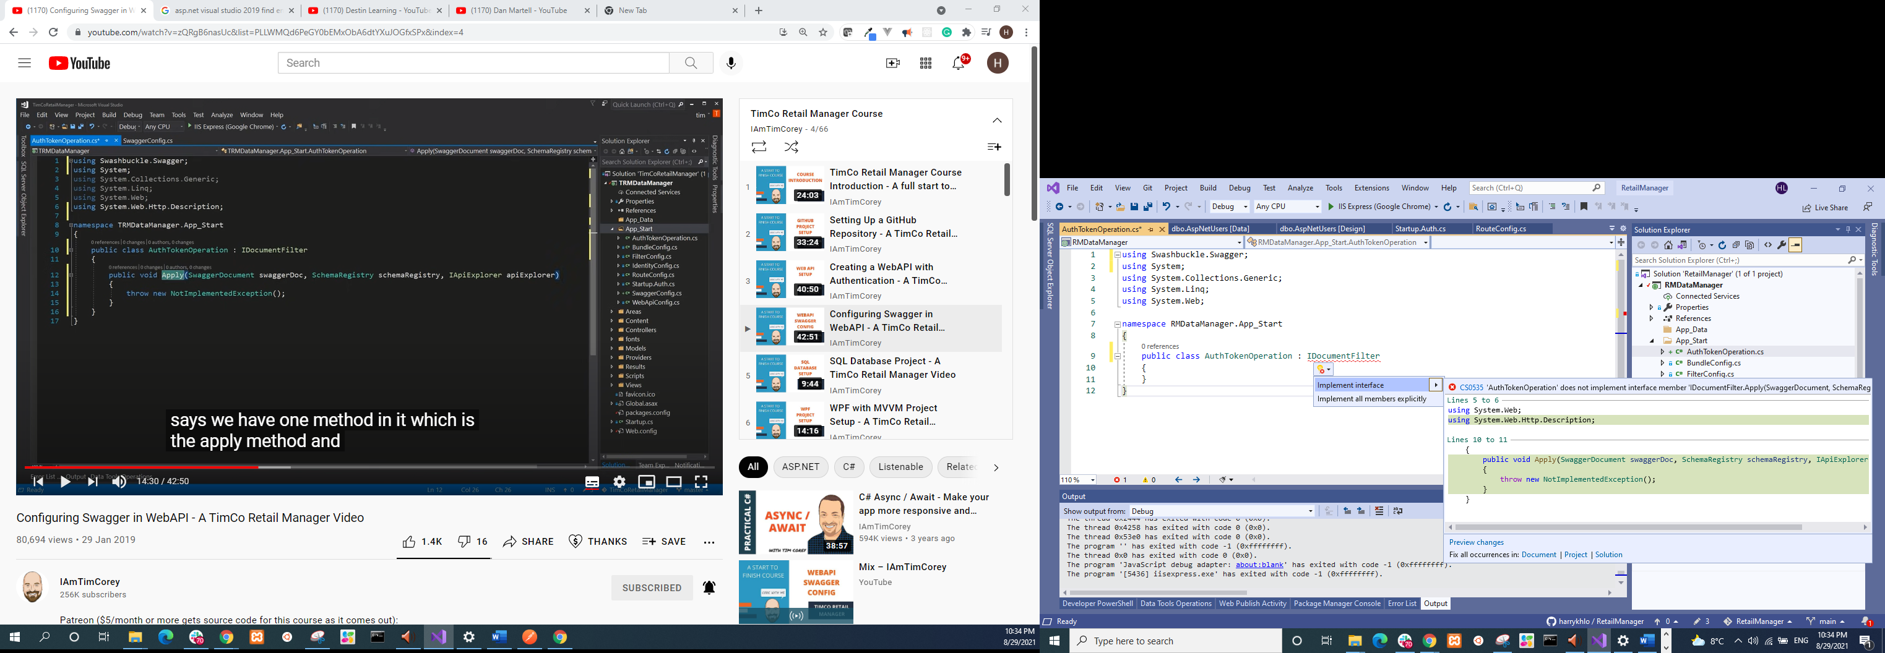

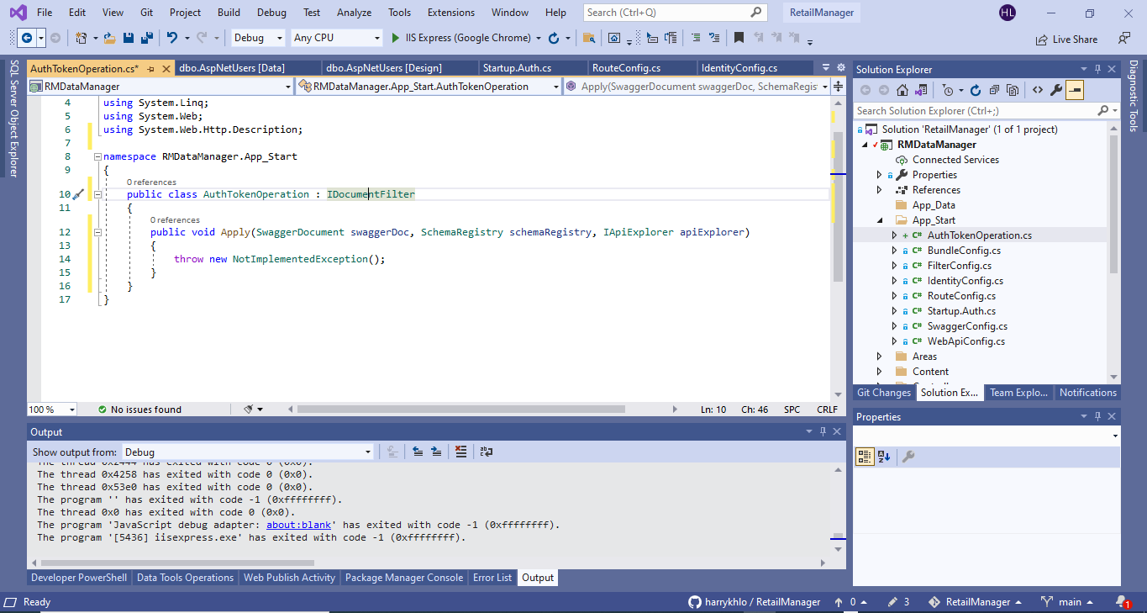

### Gave concrete implement of the interface “IDocumentFilter”

The detailed implement sees AuthTokenOperation.cs

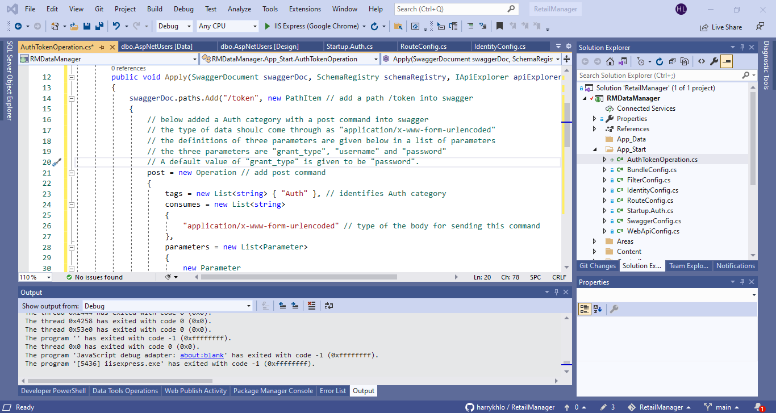

### Update SwaggerConfig.cs accordingly

Added config below:

c.DocumentFilter<AuthTokenOperation>();

Added Using below

using RMDataManager.App_Start;

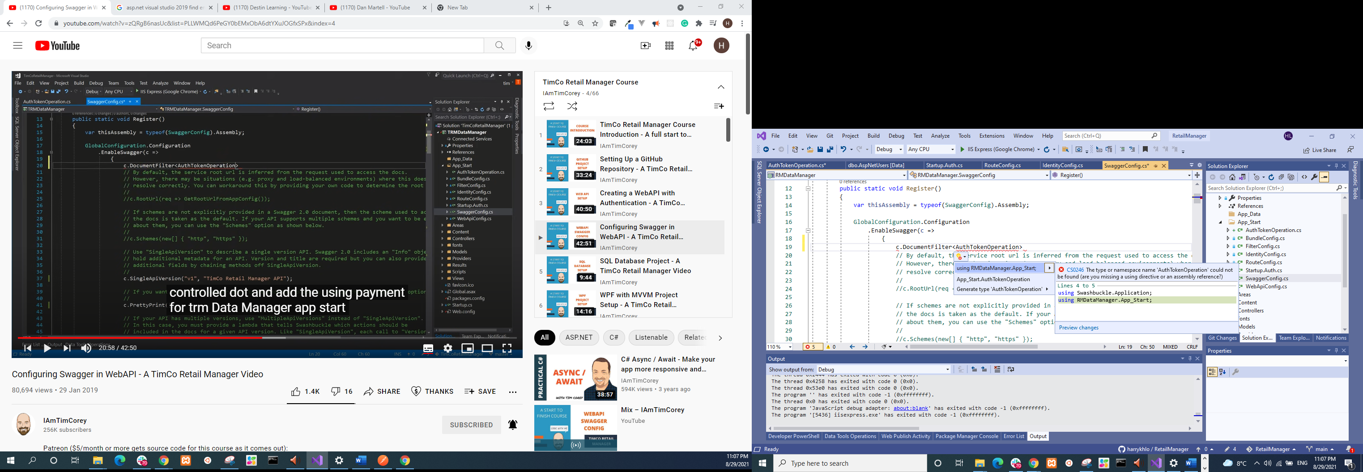

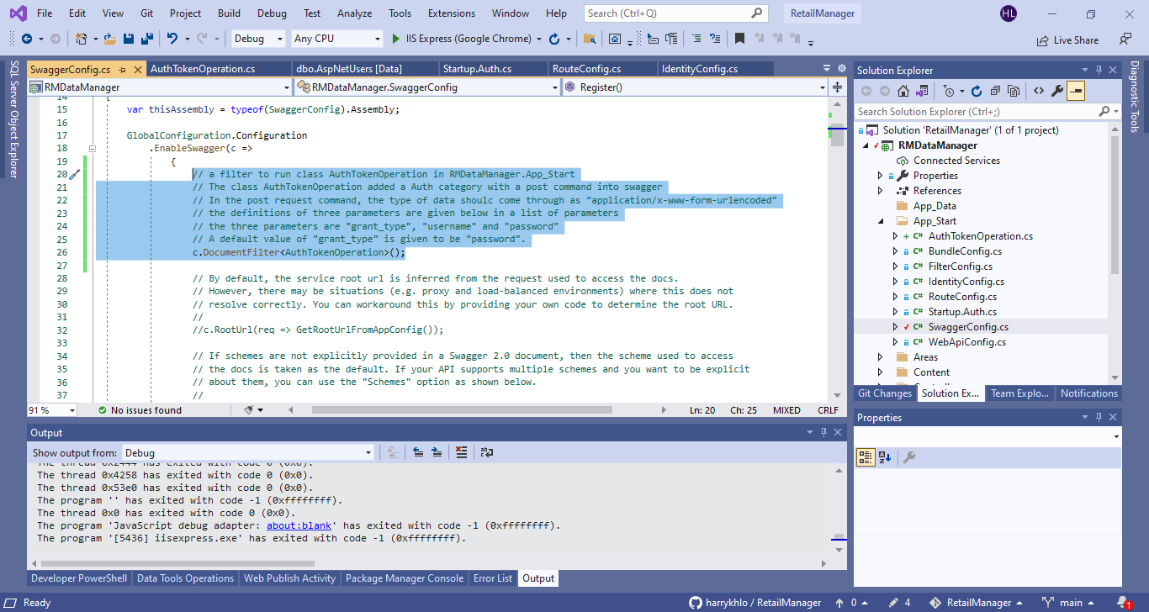

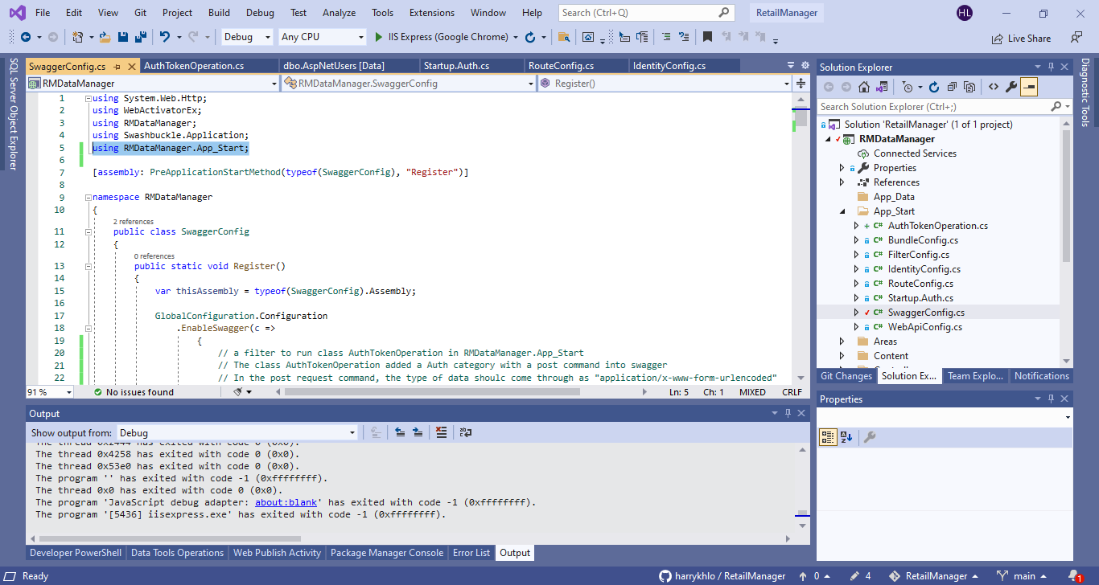

### Run the code to see swagger ui

The swagger ui can be found at <https://localhost:44375/swagger/> as shown below after run the code

There is an Auth category added.

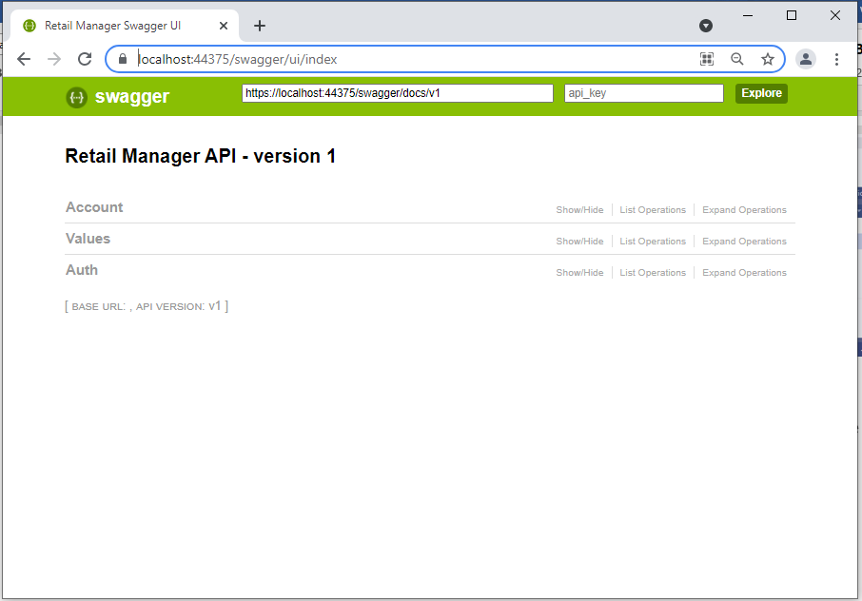

### Use the post in Auth of the Swagger UI

Filled correct username and password,

Then click “try it out”

A response is given as below screenshot and there is a token of the user in the response body

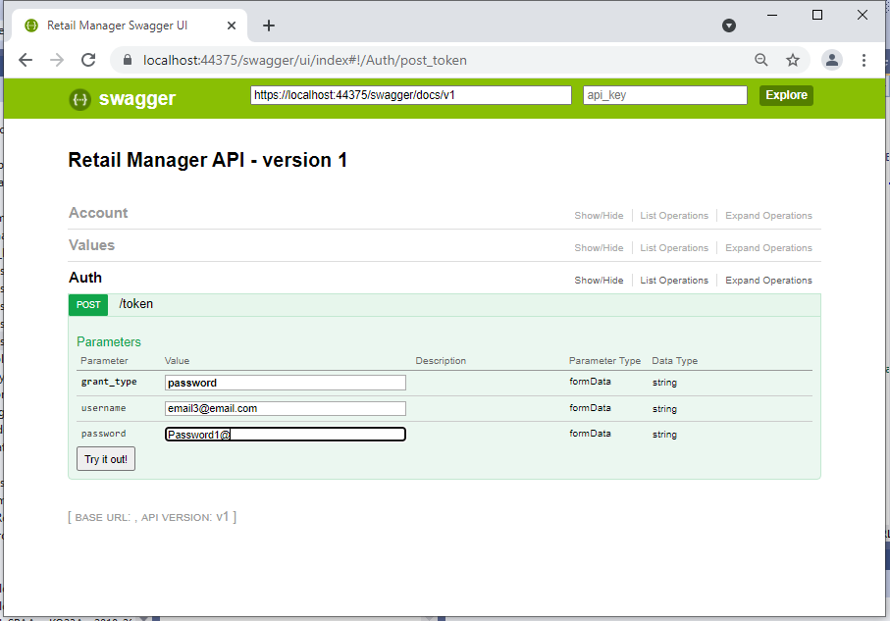

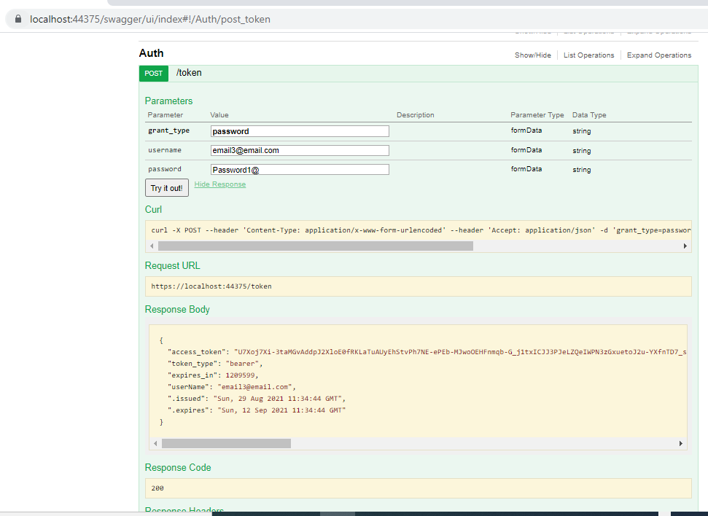

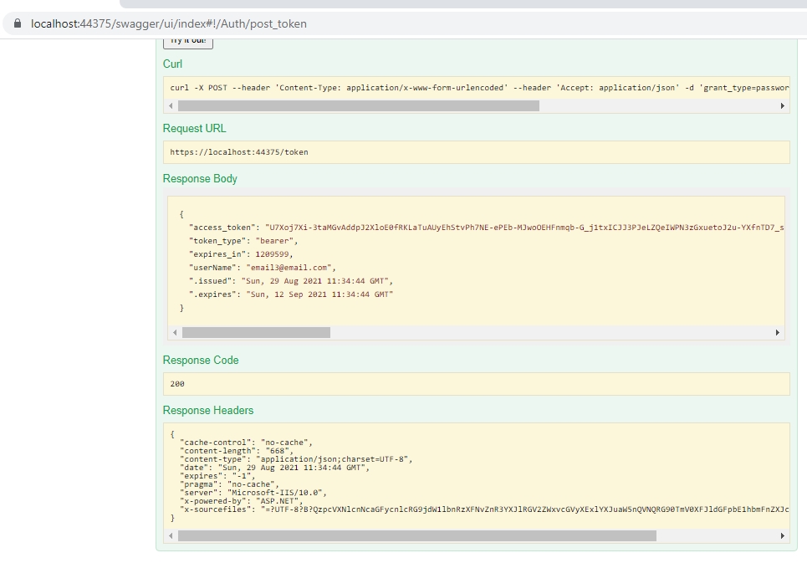

## Add token header parameter into every end point in Swagger

### Added class AuthorizationOperationFilter inherited from IOperationFilter

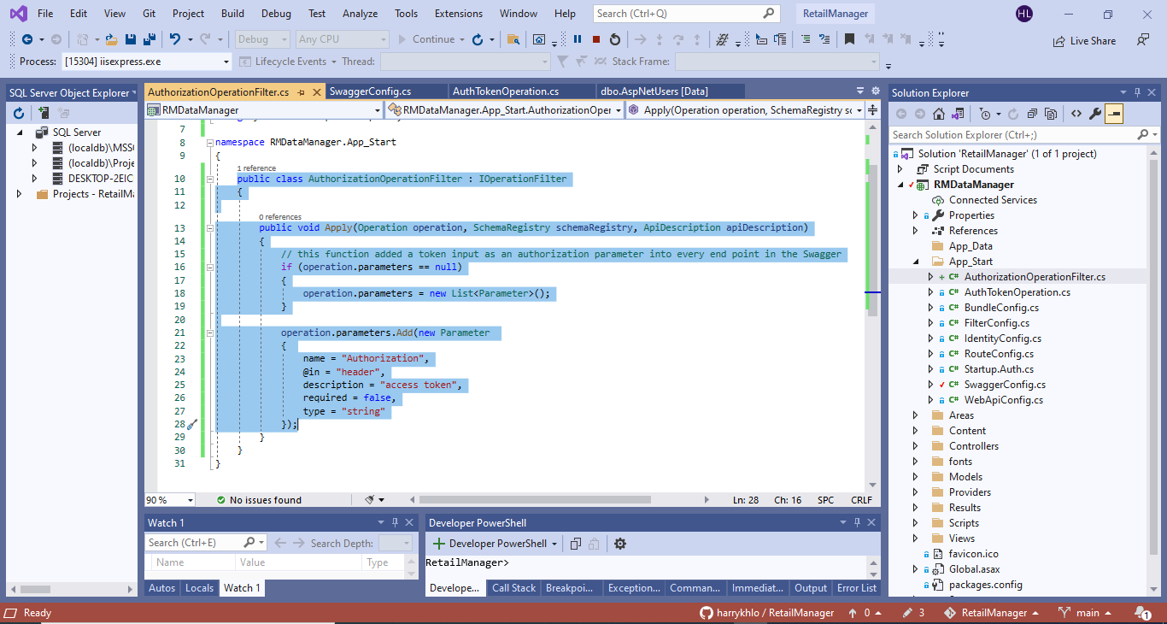

### Added c.OperationFilter<AuthorizationOperationFilter>(); into SwaggerConfig.cs

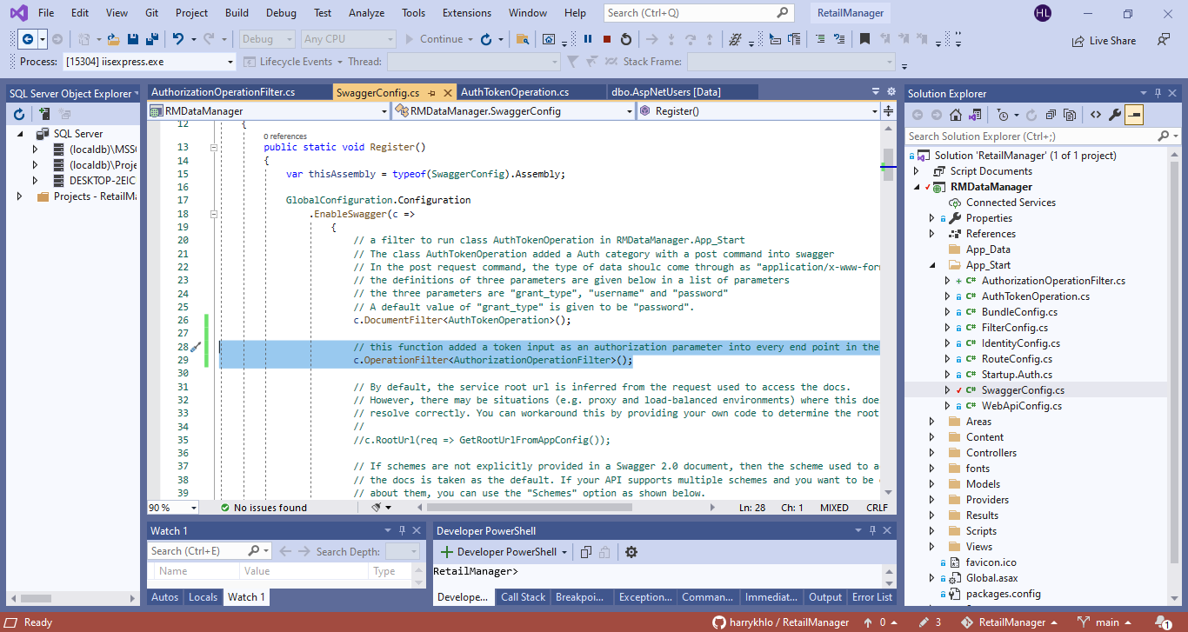

### Showed the additional token header parameter field in every endpoint of Swagger

Enter the value to be Bearer <token> as shown below:

(note: token can be obtained in the token endpoint as shown in the second endpoint below)

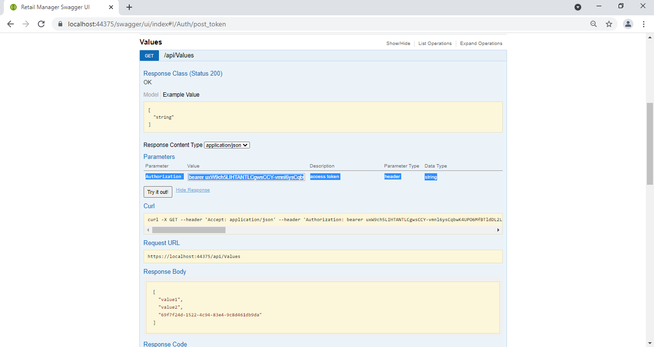

The token can be obtained in the token endpoint as shown below:

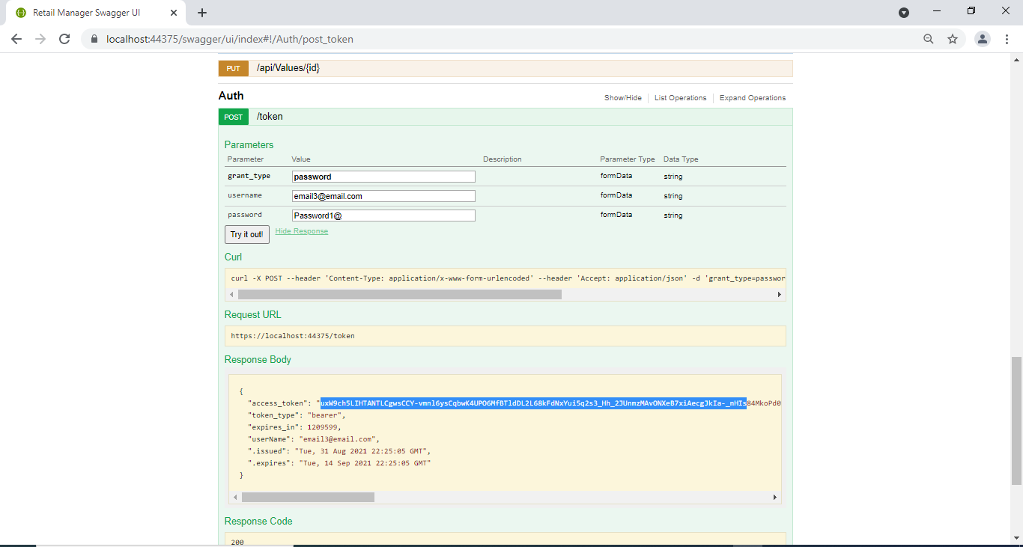

## Disable Swagger

The swagger may be only for development but not for production.

If so, Swagger can be disable by commenting the line as shown below:

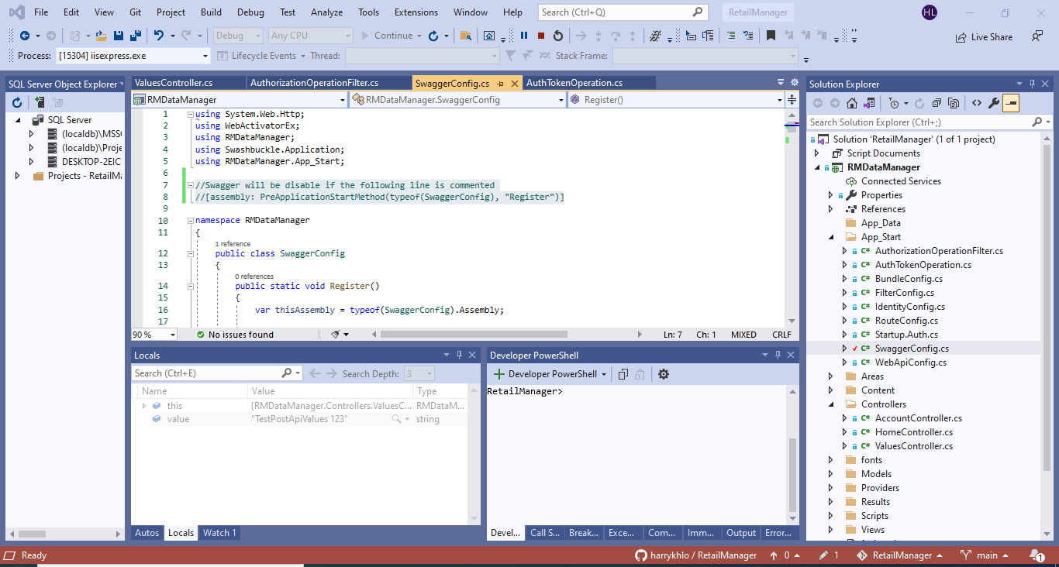

After the comment above, the Swagger became unavailable as shown below:

